Kumami World — Full Product Specification
Every product, on every tier, the exact data source & API used, and how each result is calculated. INTERNAL reference (names the data provider) — the customer-facing product never surfaces the provider name.
Version 1.9 · 10 Oct 2026 · see “Release notes” for what changed.

Contents
Right-click and choose 'Update Field' to build the table of contents.

Release notes
What changed in each version of this document, newest first. Every entry describes how the live product changed (or how the doc was corrected to match it).

v1.9 — 10 Oct 2026
- Following & Alerts: followed airdrops/whitelists are listed by their name (before, a database code like “hBpbd… (airdrop)” showed). Removed airdrops are labelled as no longer listed.
- Daily Pro Digest: each section now really shows the newest 3 items, as its header promises (before, it took the first 3 in storage order, so new posts could be missing).
- QA: every admin-managed Plus/Pro content type is now tested end to end — the superadmin test account publishes “[TEST]” items, the Pro test account checks they show correctly, the free test account sees only the teaser. Test items stay on kumami-dev until the next run.

v1.8 — 10 Oct 2026
Admin Subscriptions tool and fixes from Andrew's review. QA: docs/qa/2026-10-10-subscriptions-and-fixes.md.
- Subscriptions admin page (superadmin only). Grant Pro for 1 / 3 / 12 months or no end date, or remove Pro; works on production; audited; expiry automatic. The Profile “Grant Pro / Remove Pro” testing buttons and their endpoint were removed.
- Flow Radar Plus always shows “Delayed 15m” (it showed “Live” while loading/failing — what Andrew saw on the deployed dev site); the Console tile is now “Flow Radar Plus” with a Delayed chip.
- Exchange Netflow 24H shows “Updates daily” instead of “$0 · Neutral”.
- Sign-up name is saved to the user profile and shown in the sidebar; users can edit their name in Profile; older accounts get their sign-up name copied over on next login.
- 7-day Flow Radar history backfilled (whale transfers + liquidation spikes, 4–9 Oct) — Watchlist Pro / Spot Pulse Pro extra coins now use the full 7-day rule. Wrapped tokens excluded.
- Fixed: liquidation-history cache ignored the exchange list (could serve Binance-only data for a cross-exchange request).
- Not re-audited in this version: sections not named above.

v1.7 — 10 Oct 2026
Shipped the v1.6 planned items (planned flags removed), plus Pro-access and Calendar changes. QA: docs/qa/2026-10-10-plus-pro-tool-split.md.
- Shipped: Plus/Pro tool split — planned flags removed. Flow Radar Plus (15-min delayed snapshot, 5 coins) / Flow Radar Pro (real-time, every coin); Watchlist Plus (5 fixed) / Watchlist Pro (anchors + your coins + 5 extra coins by 7-day Flow Radar consistency); Spot Pulse tile (Plus) / Spot Pulse Pro (10 tiles, real-time). Plus pages are Plus for every account. Pro → Tools lists the three Pro tools.
- Pro = subscribed only. Admin/superadmin roles no longer grant Pro (Andrew's test account was seeing Pro after unsubscribing because it is a superadmin). Enforced in pages, sidebar and server, incl. the Crypto Address Tracker API.
- Calendar: CoinGlass feeds OFF by default; two admin switches (macro events, token unlocks) on /admin/pro-calendar.
- Fixed during QA: Spot Pulse 7D showed only HYPE (CoinGlass rate limits on a cold cache — now 3 retries with back-off); stablecoins (USDC) were picked as extra coins; Watchlist Pro pins couldn't be removed on phones; Plus Flow Radar delay hid most events (now snapshot-based).
- Testing-only (remove before main): “Grant Pro” / “Remove Pro” buttons in Profile → Subscription simulate a completed / cancelled subscription (disabled in production).
- Known security holes (not fixed, need a rules deploy): users can edit their own isPremium/role, create active subscriptions, and read pro_* content without subscribing — see docs/security/2026-10-10-firestore-rules-pro-leaks.md.
- Not re-audited in this version: sections outside Flow Radar, Watchlist, Spot Pulse, Calendar and the Pro intro.

v1.6 — 10 Oct 2026
Planned — not live yet.
- Planned: Plus/Pro tool split — Flow Radar Plus / Flow Radar Pro, Watchlist Plus / Watchlist Pro, Spot Pulse tile (Plus) / Spot Pulse Pro (full tool). Plus is cut down and Flow Radar Plus is delayed 15 min; Pro is complete and real-time. See the “Planned changes (v1.6)” sub-sections in Plus §2, §3, §6 and Pro §5, §18, §19.

v1.5 — 10 Oct 2026
Andrew's decision: a less crowded sidebar — each workspace shows only its own tier.
- Sidebar (Plus intro, Pro intro). Basic shows only Basic items, Plus only Plus tools, Pro only Pro tabs (Home stays in all three). Previously Plus also listed every Basic item, and Pro listed Pro + Plus + Basic.
- Workspace follows the page. Opening a page switches the Basic / Plus / Pro toggle to its tier; switching the toggle goes to that workspace's home page. Fixes Calendar, Flow Radar, Fear & Greed and Settings showing the Basic workspace (they weren't registered as Plus pages).
- Watchlist Pro (Pro §19). Pro sections (your pins, Also Worth Watching) now follow the account, like Flow Radar Pro, so Pro users keep them when they open Watchlist from the Plus workspace.
- Not in Rachelle's spec (her doc only asks for a regrouped, collapsible sidebar) — product decision by Andrew, 10 Oct 2026.

v1.4 — 10 Oct 2026
First release under the new development workflow (docs/DEVELOPMENT_WORKFLOW.md): two bugs found by the first Playwright QA pass, fixed.
- Calendar (Plus §5). Repeated macro releases (same name, country and time) are now shown once — they previously produced duplicate entries.
- Spot Pulse alert cards (Plus §2.9, Pro §5). Amounts are shown at the right scale ($B / $M / $K) — small moves previously read “Spot buying $0M in 4H”.
- Not re-audited in this version: everything outside the two items above.

v1.3 — 9 Oct 2026
Brings the document in line with the dev branch after the 21 Sep data-integrity build and the 9 Oct Calendar / Spot Pulse build, and corrects several v1.2 statements that were already out of date.
- Calendar (Plus §5, Pro §14) — one Calendar for Plus and Pro. Pro's separate admin-only Calendar tab is retired; /world/calendar now merges the market-data feed (macro prints + token unlocks) with events the team adds at /admin/pro-calendar. Drafts stay hidden; publish/edit/delete show on the next load. Month grid with a “Next up” card replaces the old list view.
- Calendar data fixes. Macro feed now covers 30 days back → 60 days ahead (it previously returned only the past 30 days, so nothing upcoming showed and the high-impact popups could never fire). Unlocks are dated on the actual next unlock (were stamped “now”) and sized by that unlock as % of circulating supply.
- Console (Plus §1). Preview row is now Spot Pulse · Flow Radar · Calendar (next 7 days) · Watchlist. The Intelligence preview and the separate “Radar Watchlist” auto-pick engine were retired. New “Needs your attention today” popup.
- Intelligence (Plus §7) — removed from navigation; /world/intel redirects to Console. The engine still feeds Fear & Greed's News Tone.
- Spot Pulse (Pro §5) — now live in Pro, showing the same panel as Plus On-Chain Insights (faster 15s refresh for Pro). /world/spot-pulse redirects to On-Chain Insights.
- Pro navigation (Pro intro, §3, §4, §12). Smart Money Tracker, Coin/Token Tracker and the Pro Fear & Greed slot were removed (empty placeholders, absent from Rachelle's latest mockup). Pro now has 14 sidebar tabs; Security Scanner is the only placeholder left.
- Watchlist (Plus §6). Fixed 5-asset roster (BTC/ETH/SOL/BNB/HYPE) for everyone; the table now has separate Signal (whale / smart money / Spot Pulse) and Status (risk tags + regime) columns. Whale tags no longer wrongly Pro-gated.
- Fear & Greed (Plus §4). Inverted colours fixed (Extreme Greed was red); history chart gets colour bands + axis labels; the composite shows as unavailable when all five inputs fail instead of a fake neutral 50.
- All Plus panels — no stale data. The shared cache no longer serves old numbers when CoinGlass fails; panels show “No data” instead of $0 / 50 / neutral placeholders.
- Corrections to v1.2 text: Plus Flow Radar events arrive on a 30-minute delay (v1.2 said real-time / ~15 min); AI Portfolio's 24h change is a real weighted figure (v1.2 called it fabricated); Watchlist roster is 5 assets, not 10.
- Not re-audited in this version: Kumami Basic, On-Chain Insights panel thresholds (§2.1–2.8) and the Console regime formulas (§1.1–1.3) were not re-checked against code — treat them as v1.2 content.

v1.2 — 20 Sep 2026
- Added Pro §18 Flow Radar (Pro), §19 Watchlist (Pro) and §20 Crypto Address Tracker, built against Rachelle's Kumami Website (6) spec, with what shipped vs. what is deferred.

v1.1 — 15 Sep 2026
- Every feature rewritten into the standard What it is / Where it is / How the user uses it / How we build it format, with live screenshots and admin-panel walkthroughs for all admin-authored content.
- Product changes in that build: Spot Pulse moved onto the Console preview; Watchlist roster aligned to the 5-asset universe; AI Portfolio wallet import added.

v1.0 — 13 Sep 2026
- First full Basic / Plus / Pro specification: every product's data source, API and calculation, written in the same What it is / Data in / How it's calculated style as Rachelle's Kumami Plus sheet.

Kumami Basic
Kumami Basic is the free, always-on tier — the entire onboarding, learning, news, and community surface of the platform. There is no logged-out preview: the whole shell sits behind a Firebase auth gate (WorldProtected), and once inside, every Basic feature is fully open to any authenticated user regardless of premium status. The one exception is News, where individual PRO-flagged articles are visually gated as an upsell into Pro — that is an upsell mechanic layered onto Basic, not a restriction of Basic content itself.

1. Home
The brand story page — not a personalized dashboard.

What it is
The original Kumami marketing/landing page (“About Kumami”), reused verbatim inside the World shell. It is a static composition, not a per-user dashboard: Hero → Ecosystem anchor → Moving tagline → Trending News / Numbers / Blog Updates / FAQ (over a background image) → Partners → Contact → Footer.

Where it is
Tier: visible in all three workspace modes (Basic/Plus/Pro) — not gated to Basic only.
Nav path: Sidebar → Home. It is the only item that sits outside every collapsible group, directly under the brand logo/workspace switcher — always the first thing in the sidebar regardless of mode.
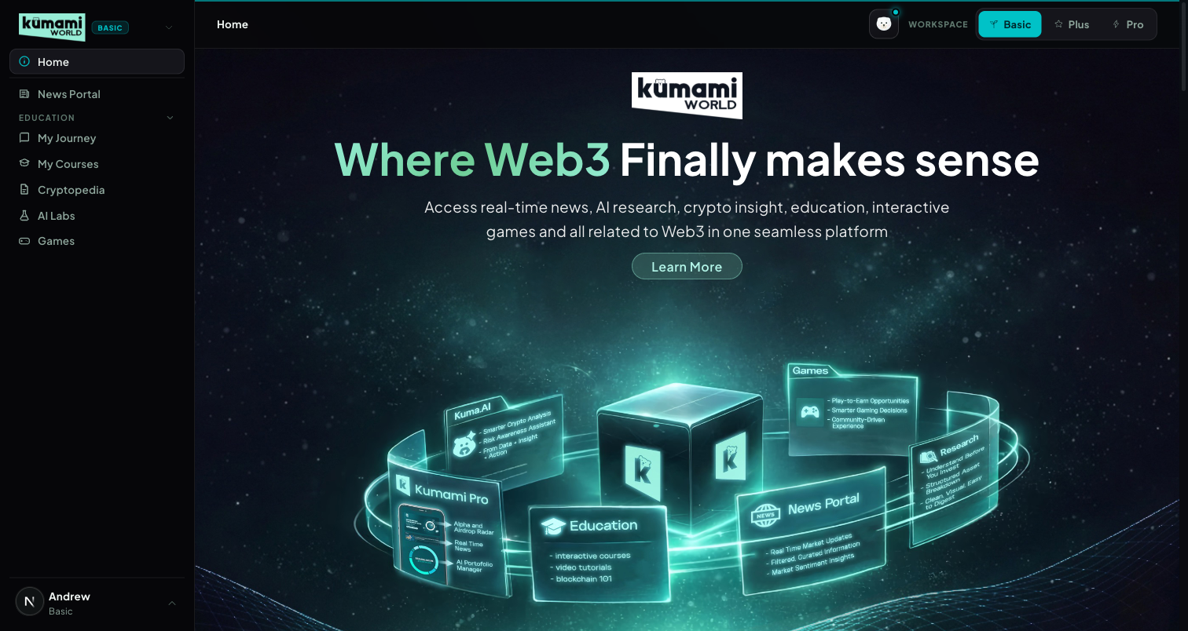
Figure: Home in Basic mode — sidebar shows Home as a standalone top item; page shows Hero → Ecosystem → Trending News → Numbers → Our Journey → FAQ → Partners → Contact → Footer.

How the user uses it
Land here after logging in, or click “Home” anytime to return. It's a scroll-and-read page: click “Learn More” in the hero to jump to the Ecosystem anchor; use the Trending News carousel's ‹ › arrows to browse recent headlines and click “Read More” to open the full article; click any Partner logo to open that partner's external site in a new tab; click “See more” under Our Journey to open the full Blogs grid; click a FAQ question to expand its answer; click “Join Our Community” to open the community CTA.

How we build it

Via API
None for the page shell itself — it's a stack of legacy marketing components with no page-level fetch.

Via Admin Dashboard (manual)
Its live sub-sections are each authored separately:
- Trending News strip — reads Firestore news (same collection/admin flow as News Portal, below).
- Our Journey blog highlight — reads Firestore blogs, authored at Content → Blog → Publish Blog (/admin/blog): Title, Read Time, Thumbnail/Detail images, Summary, Content Section 1/2 → Publish Blog or Save as Draft. Edit via Content → Blog → Edit Blog; drafts at Content → Blog → Blog Drafts.
- Partners strip — reads Firestore homepage_partners, authored at Management → Partners → Homepage Partners (/admin/homepage-partners) — a curated subset of the full directory (Management → Partners → All Partners).
Computed, not manually entered: the Total Users / Partners counters run a live Firestore .count() aggregation over the users and all_partners collections at request time — always the real current count, never hand-typed.
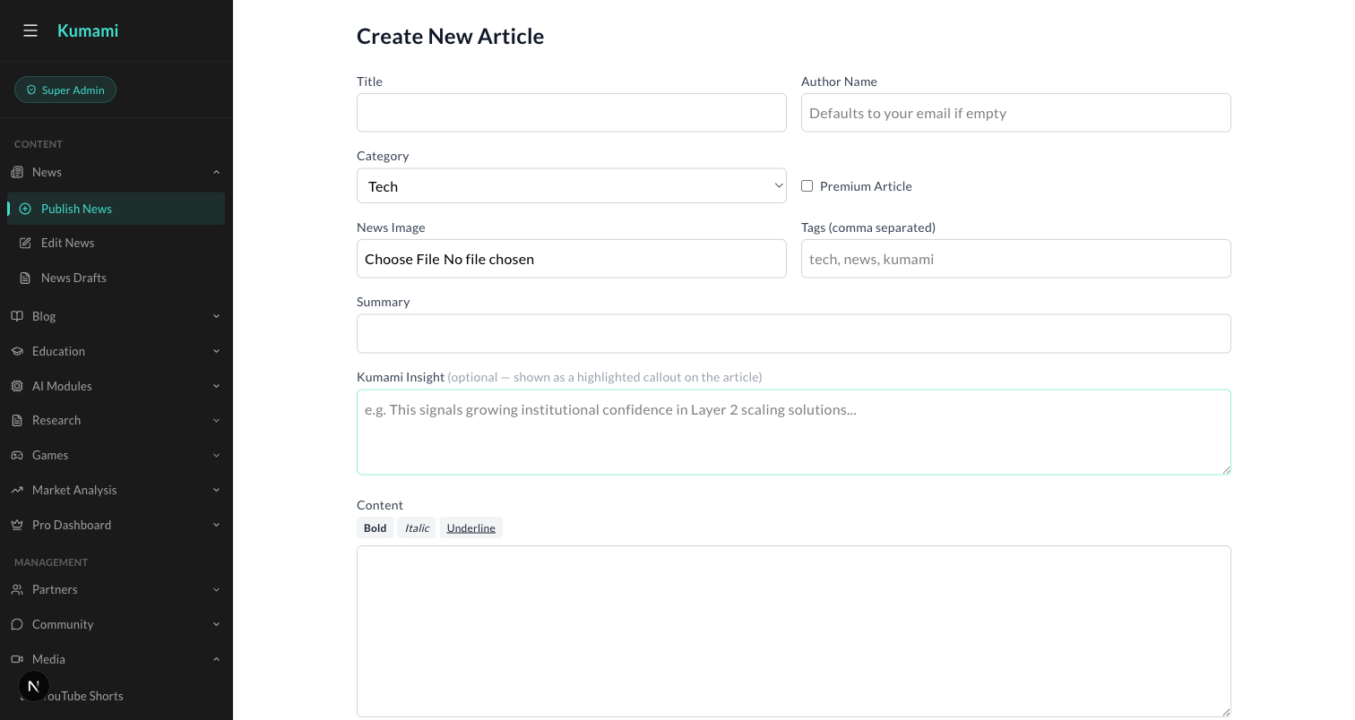
Figure: Content → News → Publish News — the admin form behind the Trending News strip and the News Portal below.
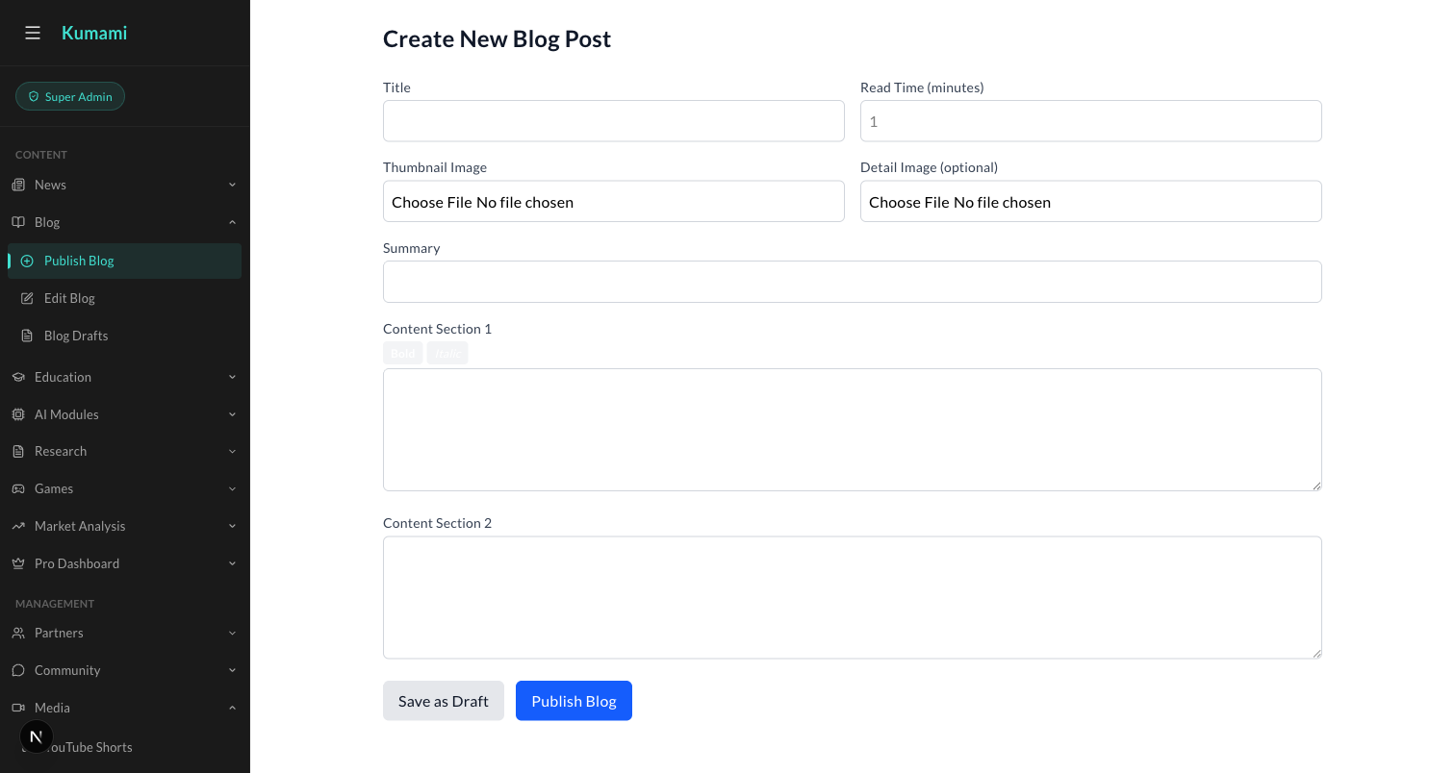
Figure: Content → Blog → Publish Blog — the admin form behind Home's Our Journey highlight.

2. News Portal
The daily crypto/Web3 news feed — hero, latest, and a river of stories.

What it is
The main news feed: a live ticker, a hero story, a ‘Latest’ aside, an upsell banner into Plus/Pro, and a river of further articles.

Where it is
Tier: Basic.
Nav path: Sidebar → News Portal (standalone item, directly below Home — not inside a group).
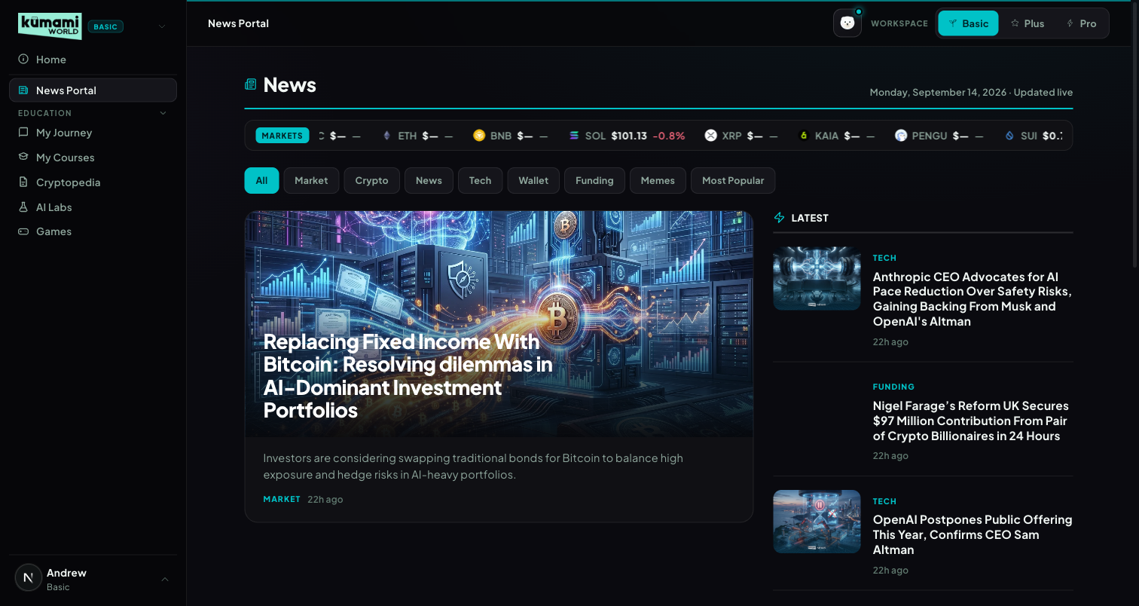
Figure: News Portal in Basic mode — live ticker, category pills, hero story, Latest aside.

How the user uses it
Read the live price ticker at the top; click a category pill (All / Market / Crypto / News / Tech / Wallet / Funding / Memes / Most Popular — pills are generated from whatever categories actually exist in Firestore, not hardcoded) to filter the river; click the hero image or headline, or any Latest/river card, to open the full article at /world/news/[id]; scroll past the “MORE NEWS” river grid and click “View all news” for the full paginated list. Articles flagged Pro in Firestore show a dimmed lock veil — clicking it routes to /world/pro instead of opening the article.

How we build it

Via Admin Dashboard (manual)
Firestore news, authored at Content → News → Publish News (/admin/news): Title, Author Name (defaults to your email if left empty), Category (dropdown), tick “Premium Article” to Pro-gate it, upload a News Image, comma-separated Tags, Summary, optional “Kumami Insight” callout box, then the main Content body → Publish. Edit existing articles via Content → News → Edit News (/admin/edit-news); unpublished work sits in Content → News → News Drafts (/admin/news-drafts).

Via API
Only the live ticker — 10 coins (BTC, ETH, BNB, SOL, XRP, KAIA, PENGU, SUI, DOGE, POL) pushed over a WebSocket (wss://tickerworker.kumamiworldapp.workers.dev/), a Cloudflare Worker proxying Binance's real-time @ticker stream — push-based, not a polling REST call, auto-reconnects 1s after any drop.
Figure: Content → News → Publish News — the exact form used to author every News Portal article.

3. Education — My Journey & My Courses
Two tabs, one underlying engine: a first-timer intro that becomes a personal dashboard once you start.

What it is
Basic's learning system: 5 fixed levels totaling 65 lessons (~19 hours), each tracked per-user at chapter and section granularity. ‘My Journey’ is a smart tab — first-time visitors see an intro/level-picker; anyone with any progress sees the Dashboard experience instead, automatically, with no separate setting to toggle.
# | Tag | Title | Badge | Duration | Chapters
1 | Beginner | Start Here | First Steps | 2h 10m | 7
2 | Elementary | Understand What You Just Bought | Under the Hood | 3h 40m | 12
3 | Intermediate | Learn to Trade | Sharp Eye | 5h 05m | 17
4 | Advanced | Think Like an Investor | Market Mind | 3h 55m | 12
5 | Expert | Go Deeper | Web3 Native | 4h 20m | 12

Where it is
Tier: Basic.
Nav path: Sidebar → Education (collapsible group) → My Journey, or Sidebar → Education → My Courses.
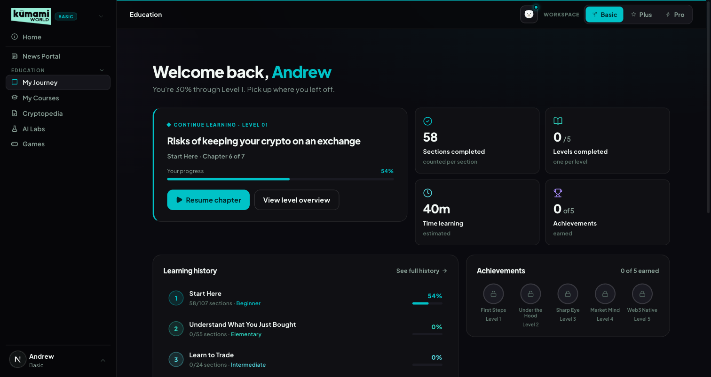
Figure: My Journey, returning-user Dashboard state — welcome banner, Continue Learning card, stats, learning history, achievements.
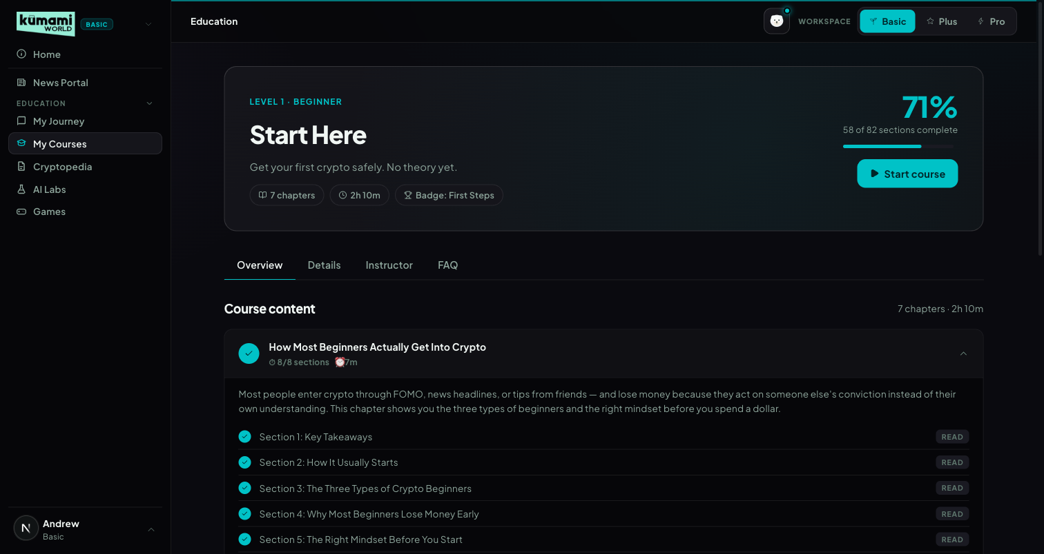
Figure: My Courses, Level 1 detail — progress bar, Overview/Details/Instructor/FAQ tabs, chapter accordion with per-section Read checklist.

How the user uses it
First-time state (My Journey): click a level card, or the “Start Level 1” CTA, to begin. Returning state (My Journey): the same tab now shows a Dashboard — click “Resume chapter” on the Continue Learning card to jump straight back into the exact chapter/section left off, or “View level overview” to see the full level. My Courses: pick a level (via the level cards or the ?level=1-5 URL), work through the Overview tab's chapter accordion, click “Read” on each section to mark it complete, and switch to Details / Instructor / FAQ for the level blurb, instructor bio, and the FAQ (which states plainly that all 5 levels are completely free).

How we build it

Via Admin Dashboard (manual)
Chapter content lives in Firestore education_articles, authored at Content → Education → Publish Education (/admin/education): choose Level (dropdown, Level 1-5) and Chapter position (0-based index — sets ordering within that level; the article title becomes the chapter name), Author, Read time, tick “Featured lesson” or “Coming soon” (placeholder, no content yet) as needed, Blurb (1-2 sentence card summary), Description (SEO meta), Thumbnail, then build the body in Content Sections using either the Classic or TipTap editor — a Live Preview panel mirrors the breadcrumb and content live as you type. Edit via Content → Education → Edit Education; drafts sit at Content → Education → Education Drafts.

Via API
None — progress is per-user Firestore state, not an external fetch. Stored at users/{uid}/education_progress/{levelNum} (falls back to localStorage when logged out). Progress % is section-based, not chapter-based: pct = round(completedSections / totalSections × 100), summed per level and overall on the Dashboard.
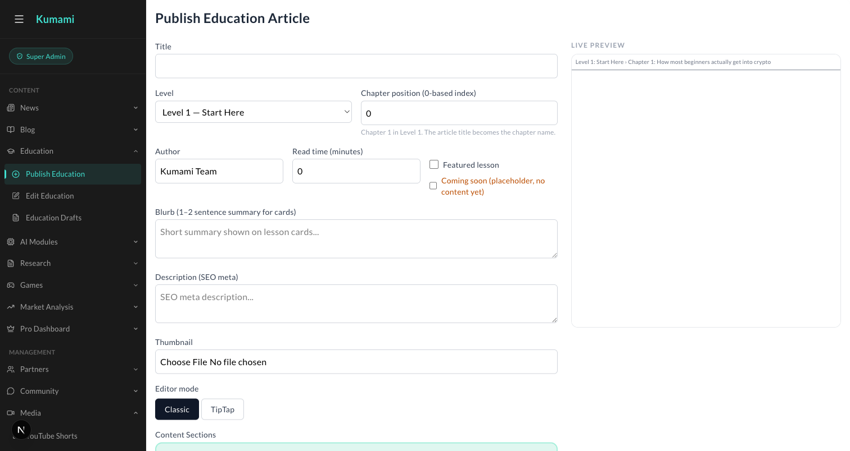
Figure: Content → Education → Publish Education — Level dropdown, Chapter position, Content Sections editor with Live Preview.

4. Cryptopedia — Tokenpedia & Glossary
An onchain asset directory and a plain-language glossary, unified under one capsule selector.

What it is
A reference-desk tab with an underline-style capsule toggle between two views: Tokenpedia (?view=tokenpedia, default) and Glossary (?view=glossary).

Where it is
Tier: Basic.
Nav path: Sidebar → Education (group) → Cryptopedia — its own item alongside My Journey/My Courses inside the same group.
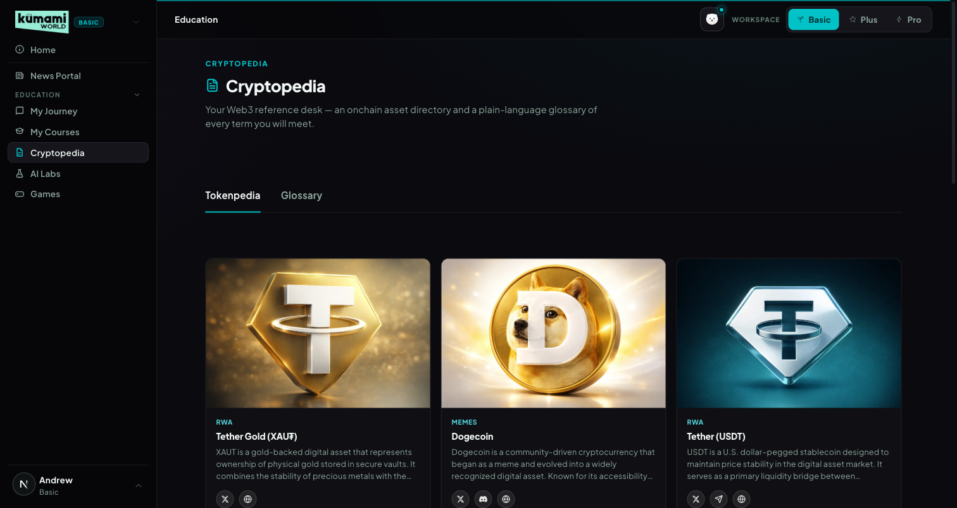
Figure: Cryptopedia → Tokenpedia view — card grid of on-chain assets/projects with social links.
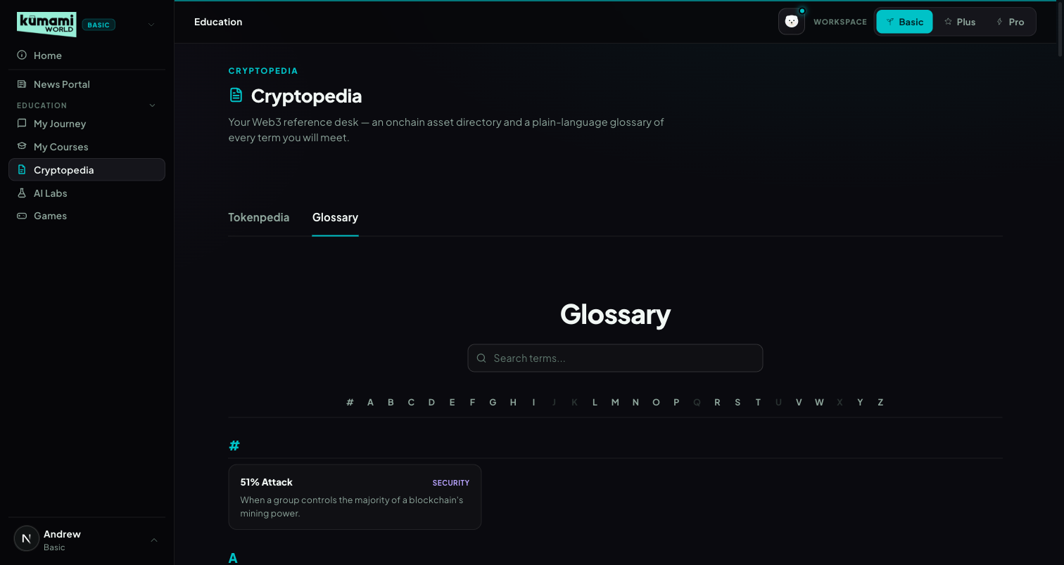
Figure: Cryptopedia → Glossary view — searchable, A–Z indexed term list.

How the user uses it
Land on Tokenpedia by default — click any project card to open its detail page (/world/research/[id]) with its description and X/Discord/Telegram/Website links. Click the “Glossary” capsule to switch views; type in the search box (matches term/definition/category) or click a letter in the A–Z index to jump; click any term to open its detail page (/world/glossary/[id]).

How we build it

Tokenpedia — Via Admin Dashboard (manual)
Firestore research_articles, authored at Content → Research → Publish Research (/admin/research): Title, Author, Category (dropdown, e.g. “Web 3 Platform”), Research Image (Main), Short Description, one or more Content Sections, optional Detail Image 2 → Publish. Edit via Content → Research → Edit Research; drafts at Content → Research → Research Drafts.

Glossary — Via Code only
No admin panel today: a fully static file, src/data/glossaryData.ts — 147 hardcoded {id, term, category, definition} entries, no Firestore involved. Adding or editing a term currently requires a developer to change that file and deploy — there is no admin UI for it. Flagged here as a gap if the team wants to manage terms without a developer.
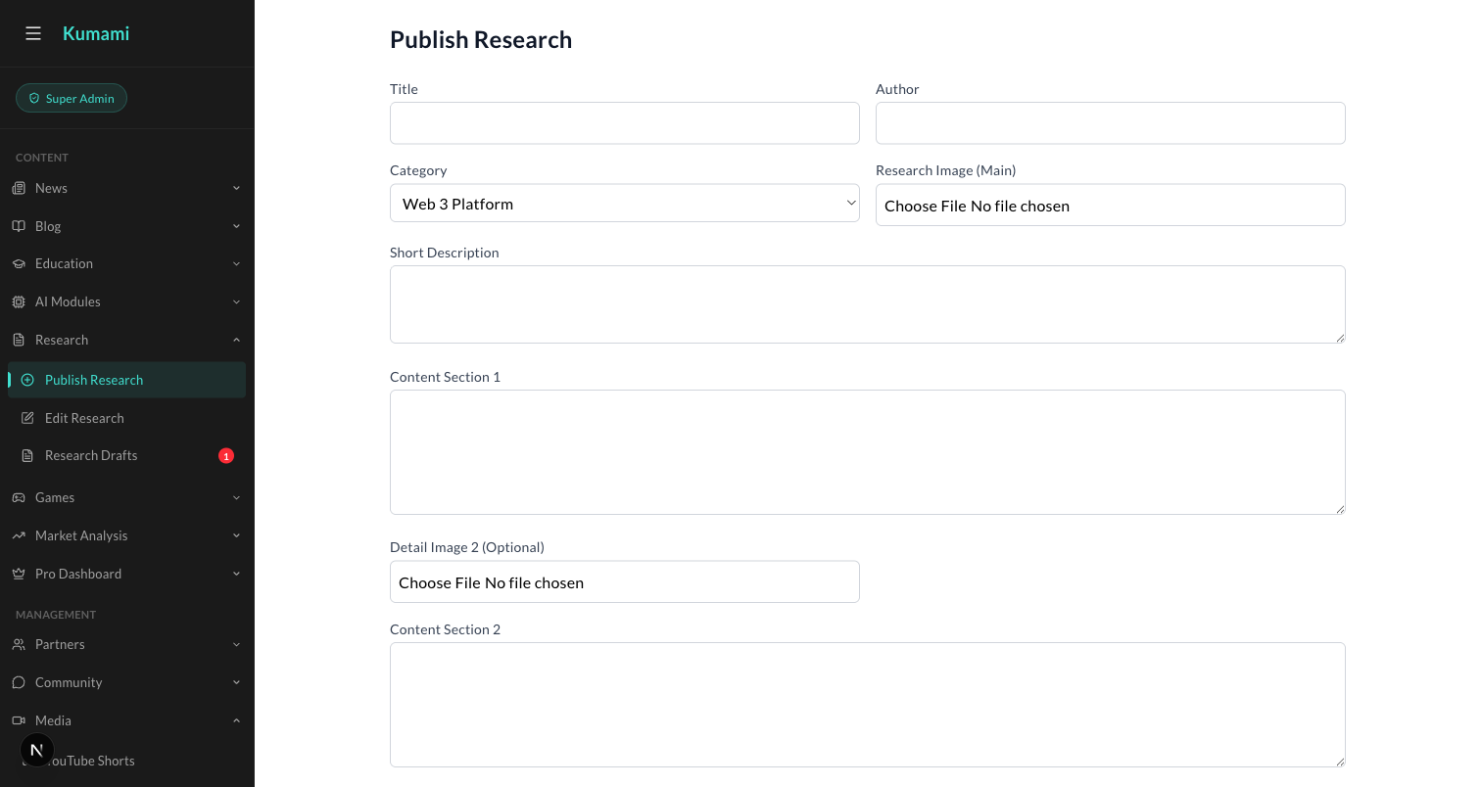
Figure: Content → Research → Publish Research — the admin form behind every Tokenpedia card.

5. AI Labs
A marketing placeholder for an upcoming AI + Web3 hub — no live tools yet.

What it is
An informational page previewing 3 planned features. 100% static — a hardcoded featureCards array, no Firestore, no API.

Where it is
Tier: Basic.
Nav path: Sidebar → AI Labs (standalone item, below the Education group).
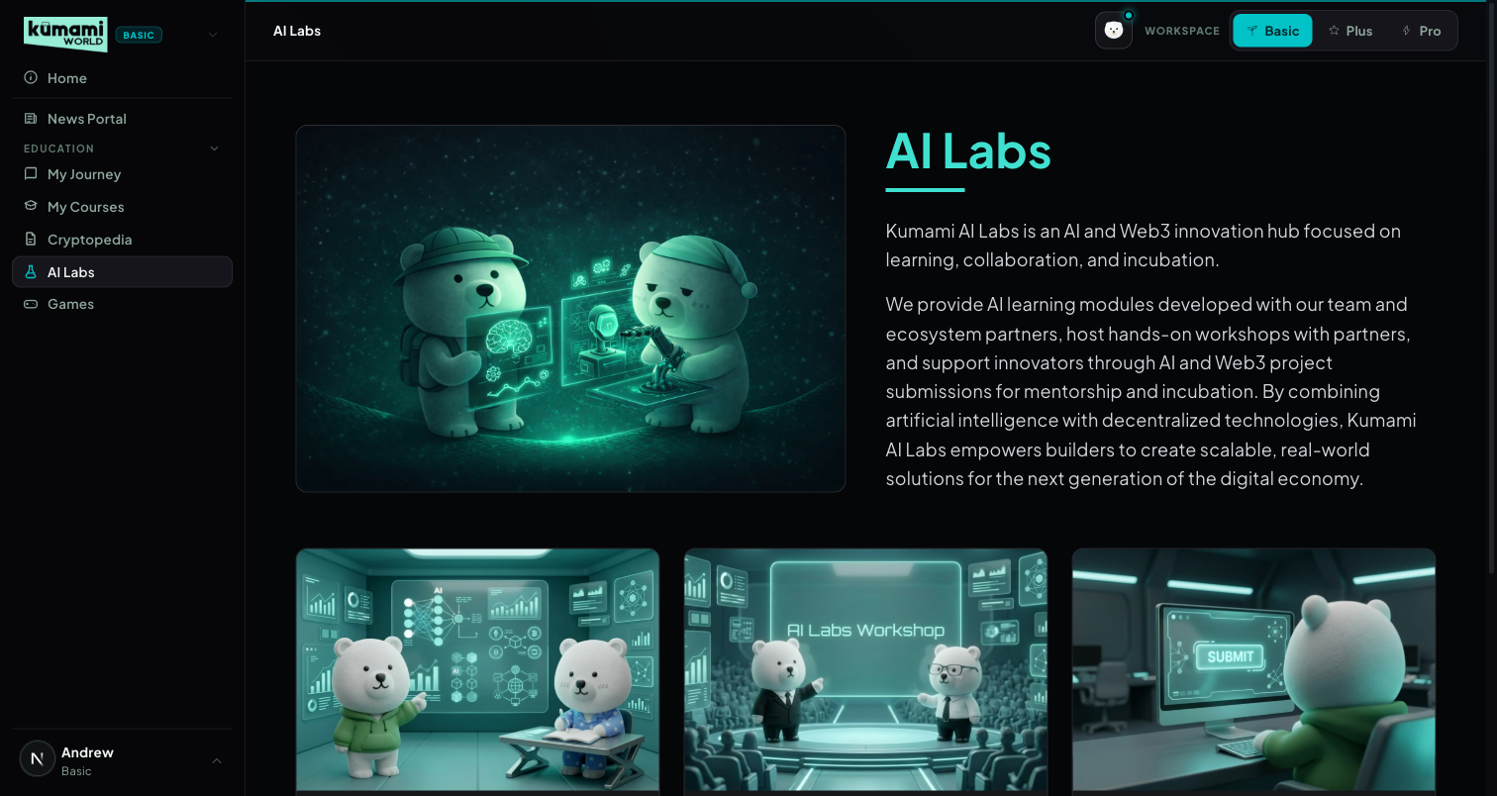
Figure: AI Labs — hero + intro copy, 3 “Coming Soon” feature cards (Module, Workshop, Submission).

How the user uses it
Read-only today — scroll through the hero and the 3 feature cards. Each card's button is disabled and reads “Coming Soon”; there is no interactive action to take yet.

How we build it

Via Code only
A hardcoded featureCards array inside the page component. No Firestore, no API, no admin panel — any copy or card change requires a developer to edit the code and deploy.

6. Games
An interactive-learning games catalog with a featured carousel and category rails.

What it is
A games portal: a featured carousel plus category-filtered rails (Most Popular, Free to Play, Coming Soon).

Where it is
Tier: Basic.
Nav path: Sidebar → Games (standalone item, bottom of the Basic sidebar).
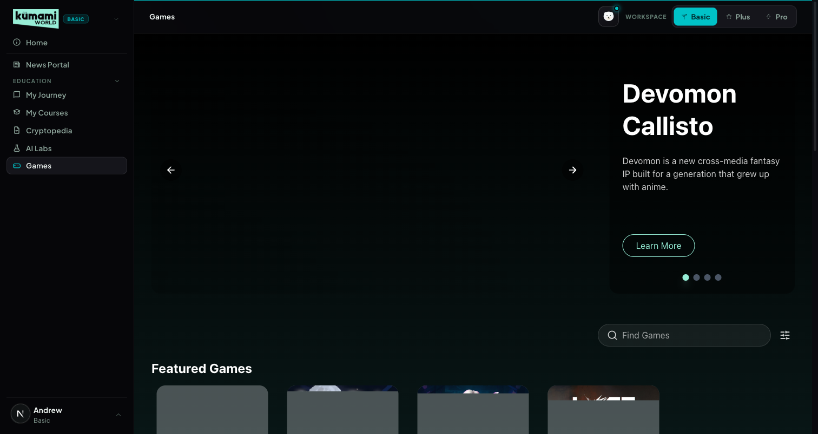
Figure: Games — featured carousel, search + platform filter, category rails below.

How the user uses it
Browse the auto-advancing featured carousel (every 8s) or use the ‹ › arrows / pagination dots to control it manually; type in “Find Games” to search by title/tagline/genre/platform, or open the filter icon to tick a Platform (PC / Website / Mobile App); scroll the All Games, Most Popular, Free to Play, and Coming Soon rails below; click any game card to open its detail page (/world/games/details?name=<title>); click “View More” on the All Games rail to see the full catalog.

How we build it

Via Admin Dashboard (manual)
Firestore games, authored at Content → Games → Publish Games (/admin/games): Game Title, Tagline, Genres (checkboxes), Networks (checkboxes), Platform Types (checkboxes), Categories (Featured / Free to Play / Most Popular / Coming Soon — checkboxes), Released On date, plus multiple image variants (portrait/catalog/landscape/detail/carousel) → Publish. Edit via Content → Games → Edit Games; drafts at Content → Games → Game Drafts.

Via API
None.
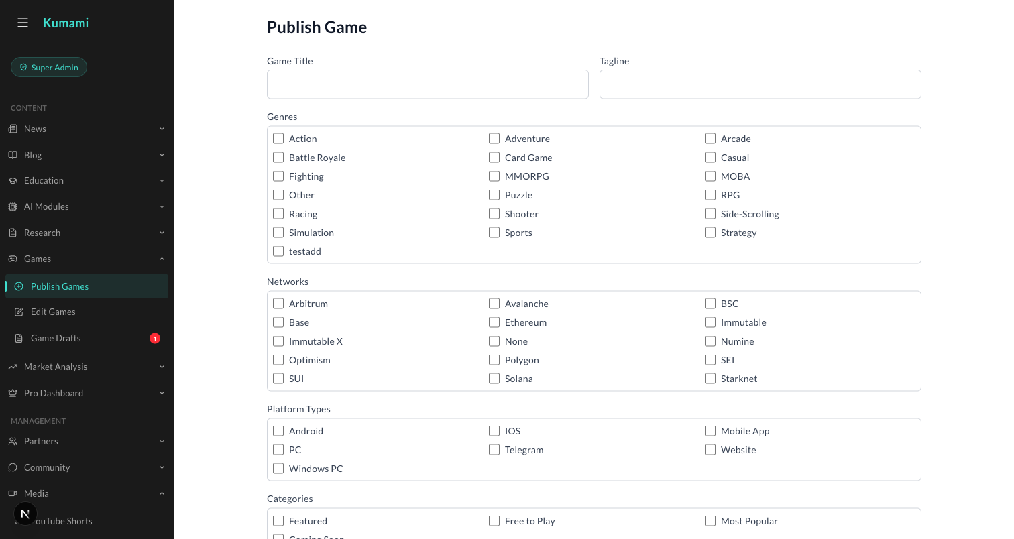
Figure: Content → Games → Publish Games — the admin form behind every Games catalog entry.

Kumami Plus
Kumami Plus is the “Advanced” tier — a fixed 5-asset universe (BTC, ETH, SOL, BNB, HYPE) across 7 tools in the sidebar: Console, On-Chain Insights, Flow Radar Plus, Fear & Greed, Calendar, Watchlist Plus and Settings. Every panel runs through the same 4-stage pipeline: (1) live data fetched from the CoinGlass v4 API, (2) cached briefly and shared across panels, (3) fed into a rule engine that converts raw numbers into a verdict + color using fixed thresholds, and (4) rendered. The interpretation layer — not the data — is the product. The cache never serves stale data: if an upstream call fails, that panel shows “No data” rather than old numbers or a $0 / 50 / neutral placeholder. Flow Radar Plus (its own tab and the Console feed) shows the feed as it was 15 minutes ago — for every account, Pro included (FREE_TIER_DELAY_MINUTES, served from saved snapshots); other panels are not delayed. Pro removes the delay and widens the asset universe (see the Kumami Pro section). Spot Pulse has no tab of its own — it lives inside On-Chain Insights (§2.9) and on the Console; Intelligence was removed from the navigation on 21 Sep 2026 (§7).
Plus vs Pro versions (since v1.7): Flow Radar, Watchlist and Spot Pulse each exist in a cut-down Plus version (Plus pages, every account) and a complete, real-time Pro version (Pro → Tools: Flow Radar Pro, Watchlist Pro, Spot Pulse Pro, subscribers only). Plus pages always behave as Plus — Pro accounts and admins see exactly what Plus users see there.
Navigation (since 10 Oct 2026): each workspace's sidebar shows only its own tier — Basic shows Basic, Plus shows Plus, Pro shows Pro (Home stays at the top in all three). The workspace follows the page: opening any page switches the Basic / Plus / Pro toggle to that page's tier, and switching the toggle jumps to that workspace's home page (Basic → My Journey, Plus → Console, Pro → AI Portfolio). Shared pages (Home, About, Blogs, Profile) keep the current workspace.

1. Console
The 10-second daily briefing — aggregates every other Plus tool onto one screen.

What it is
The first screen Plus users land on. Fuses market sentiment, four macro tiles, five per-asset regime chips, and live previews of Spot Pulse, Flow Radar, the Calendar (next 7 days) and the Watchlist — all in one scroll, zero extra clicks. A “Needs your attention today” popup flags high-impact events landing in the next 24 hours.

Where it is
Tier: Plus.
Nav path: Sidebar → Plus (group) → Console. Console is also the landing page you reach first when you switch to the Plus workspace.
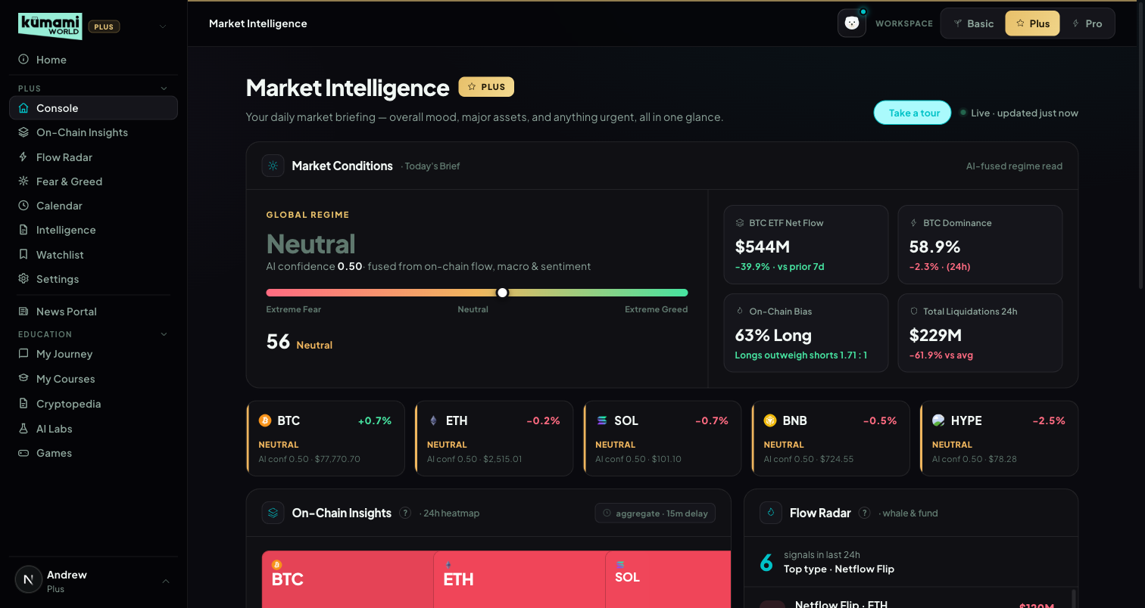
Figure: Console — Market Conditions regime, 4 macro tiles, 5 asset regime chips, and preview panels below.

How the user uses it
Scroll top to bottom for the full briefing: read the Global Regime word and confidence score, glance at the 4 macro tiles (BTC ETF Net Flow, BTC Dominance, On-Chain Bias, Total Liquidations 24H), check each of the 5 asset regime chips (BTC/ETH/SOL/BNB/HYPE), then use the preview panels below (Spot Pulse, Flow Radar, Calendar, Watchlist) as jump-off points — each has an “Open X →” link into its full tab. If the attention popup appears, read it and click Dismiss (it won't show those events again in this browser).

How we build it

Via API

1.1 Market Conditions — Global Regime & Fear/Greed
Data in: Fear & Greed index (0–100), 7-day BTC/ETH ETF flow direction, OI-weighted funding rate, OI-vs-price trend.
API: /api/index/fear-greed-history · /api/etf/bitcoin/flow-history · /api/etf/ethereum/flow-history · /api/futures/funding-rate/oi-weight-history · /api/futures/open-interest/aggregated-history · /api/futures/pairs-markets
How it's calculated: 4 inputs, each scored −1/0/+1, summed, then NORMALIZED by dividing by the count of non-zero (“active”) signals — a deliberate fix over a raw fixed-threshold sum, so the verdict stays meaningful even when some signals return neutral rather than diluting the bands with dead weight. Long/Short bias is intentionally NOT part of this composite — it still drives the standalone On-Chain Bias macro tile below, just not this score.
Signal | Scoring
Fear & Greed | 0–45 → +1 (contrarian) · 46–55 → 0 · 56–100 → −1
ETF Flow (7D) | positive 7D flow → +1 · 0 → 0 · negative → −1 (pre-scored by caller)
Funding Rate | > +0.10% → −1 (overheated long) · 0…+0.10% → 0 · negative → +1 (contrarian bullish)
OI vs Price | both rising → +1 · OI rising + price flat → −1 · everything else → 0
Normalized score = (sum of the 4 scores) / (count of non-zero scores). Verdict bands on the NORMALIZED score:
Normalized score | Verdict | Color
≥ +0.60 | Strongly Bullish | green
+0.25 to +0.60 | Cautiously Bullish | grey-green
−0.25 to +0.25 | Neutral | grey
−0.60 to −0.25 | Cautiously Bearish | grey-red
< −0.60 | Strongly Bearish | red
Confidence floor (share of active signals agreeing with the winning direction): ≥0.75 → show the full verdict · 0.60–0.75 → “Leaning [Bullish/Bearish]” · <0.60 → “Neutral · Low Signal” regardless of the raw verdict.
Sentiment extremes are contrarian; fusing 4 independent signals reduces false-confidence single-indicator whipsaws.

1.2 Macro Tiles (4 tiles)
Tile | API | Calculation | Refresh
BTC ETF Net Flow | /api/etf/bitcoin/flow-history | Sum of last 7 daily flows vs. the prior 7-day window; “$X · +Y% vs prior 7d” | daily, after US close
BTC Dominance | CoinGecko /api/v3/global (free, no key) | BTC's share of total crypto market cap + 24h market-cap-wide change. Rising = risk-off; falling = risk-on/alt-season. | 15 min
On-Chain Bias | /api/futures/global-long-short-account-ratio/history (BTC-USDT, 1h) | % long + ratio, both derived from the same API response row | 15 min
Total Liquidations 24H | /api/futures/liquidation/coin-list + /api/futures/liquidation/aggregated-history | 24h liquidations across all coins vs. trailing hourly average; “$X · ±Y% vs 7D avg” | 15 min

1.3 Regime Chips — BTC / ETH / SOL / BNB / HYPE
One card per asset — price, 24h change, the same fused regime engine as 1.1 scoped to that asset, and its own confidence score. Fetched via /api/futures/pairs-markets (all 5 batched in one call) plus the same funding/OI/L-S endpoints, scoped per asset. Each asset runs the engine fully independently — no inheriting BTC's confidence. HYPE has fewer reliable signals in practice. Refreshes every 5 minutes.

1.4 Preview Panels
Preview | Logic | Footer
Spot Pulse preview | The same 5 Spot Pulse tiles as On-Chain Insights §2.9 (asset, verdict, price move) | “Open Spot Pulse →” (On-Chain Insights)
Flow Radar preview | Latest events from the shared Flow Radar event buffer (30-min delay for non-Pro) | “Open Flow Radar →”
Calendar preview | Day-by-day agenda for the next 7 days from the shared Calendar (§5). Up to 3 rows per day — team (Kumami) events first, then HIGH → LOW impact, then time — with a “+N more” line | “Open Calendar →”
Watchlist preview | The same fixed 5-asset roster as the Watchlist tab (§6), most notable signal first, “Quiet” assets last | “Open Watchlist →”
Retired on 21 Sep 2026: the Intelligence preview (replaced by the Calendar preview) and the separate “Radar Watchlist” auto-pick engine, which could show different assets than the real Watchlist. Console and the Watchlist tab now read the same data, so they can never disagree.

1.5 “Needs your attention today” popup
Fires when Console loads if any Calendar event is HIGH impact, starts within the next 24 hours, involves BTC, ETH, SOL, BNB or HYPE (or was added by the Kumami team), and hasn't been dismissed in this browser. Lists up to 5 such events with a countdown (“In 3h”). Dismiss hides those events for good (localStorage). Same rule as the Calendar's own D-1 popup (§5). Not built: the mockup's airdrop “you are eligible” line — there is no per-user eligibility data, so it would be fabricated.

2. On-Chain Insights
Market-structure deep dive per asset — 8 independent panels plus the Spot Pulse verdict grid.

What it is
Selectable asset (BTC/ETH/SOL/BNB/AVAX) and range (24H/7D/30D) driving 8 independent panels, each a chart + verdict tag + one-line headline, plus the embedded Spot Pulse panel (§2.9). Every panel is wrapped in its own try/catch — a failing endpoint degrades just that one panel to “No Data” rather than failing the page.

Where it is
Tier: Plus.
Nav path: Sidebar → Plus (group) → On-Chain Insights.
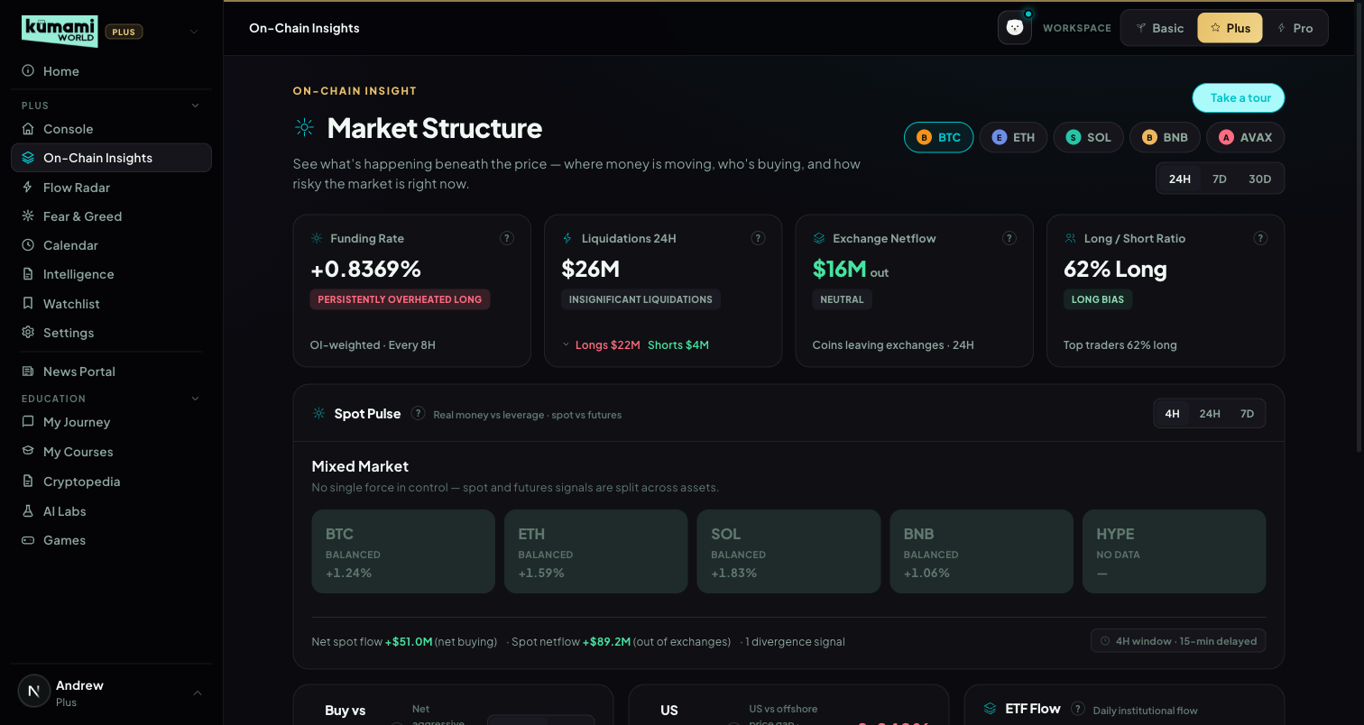
Figure: On-Chain Insights — asset/range selector, Funding Rate / Liquidations / Exchange Netflow / Long-Short tiles, and the embedded Spot Pulse panel.

How the user uses it
Pick an asset tab (BTC/ETH/SOL/BNB/AVAX) and a range (24H/7D/30D) at the top — every panel below re-fetches for that selection. Read each panel's colored verdict tag and one-line headline first; expand into the mini trend chart for detail. The banner reads “Data delayed 15 min · Upgrade to Pro for real-time.”

How we build it

Via API

2.1 Funding Rate
What it is: the recurring fee leveraged perpetual traders pay to hold a position — a direct read of crowd positioning.
API: /api/futures/funding-rate/oi-weight-history (OI-weighted, aggregated across exchanges). Cache: 300s.
How it's calculated: bands on the 3-cycle average funding rate; a “Persistently” modifier applies if the current band is extreme AND the last 3 cycles were all extreme in the same direction; a “· Rising Fast” tag fires if the 24h delta > +0.05%, or “· Unwinding” if an extreme reading is moving back toward zero.
3-cycle avg funding rate | Verdict | Color
> +0.15% | Overheated Long | red
+0.06% to +0.15% | Crowded Long | amber
0% to +0.05% | Neutral | grey
−0.05% to −0.01% | Mild Short Bias | grey
−0.10% to −0.06% | Crowded Short | amber
< −0.10% | Extreme Short | green
What the user sees: Funding {rate}% — {verdict} headline, “OI-weighted · Every 8H” cadence label, mini trend chart. Persistently one-sided funding is a classic squeeze setup — traders paying to stay positioned signals crowding, not conviction.

2.2 Exchange Netflow
v1.8: on the 24H range the panel shows “Updates daily — switch to 7D to see the flow” instead of a misleading “$0 · Neutral” (CoinGlass exchange balances update once a day, so a 24-hour window usually compares a value with itself).
What it is: whether coins are leaving exchange wallets (accumulation/bullish) or arriving (distribution/bearish).
API: /api/exchange/balance/list + /api/exchange/balance/chart. Cache: 600s.
How it's calculated: netUsd = −(balance change) × price (positive = net outflow = accumulation).
Net flow | Verdict | Color
≥ +$1B | Strong Accumulation | green
+$200M to <+$1B | Accumulation | green
>+$50M to <+$200M | Mild Accumulation | grey-green
−$50M to +$50M | Neutral | grey
<−$50M to >−$200M | Mild Distribution | grey-red
−$1B to ≤−$200M | Distribution | red
≤ −$1B | Heavy Distribution | red
Divergence tags (when flow is accelerating, |netUsd| > $50M, and price is moving): price up + net inflow → “Distribution into Strength” (red) · price down + net outflow → “Accumulation on Dip” (green) · price up + net outflow → “Conviction Rally” (green) · price down + net inflow → “Panic Selling” (red).
What the user sees: “{$X}M net {in/out}” colored bull/bear, verdict tag, “Coins leaving/arriving exchanges · {range}”, chart of total exchange balance (falling = bullish). Combines the flow direction with price context so a move can be read as conviction vs. panic, not just “up” or “down”.

2.3 Long/Short Ratio
What it is: how crowded the perpetual long/short trade is, plus whether top traders are positioned differently from the crowd.
API: /api/futures/global-long-short-account-ratio/history + /api/futures/top-long-short-account-ratio/history (Binance). Cache: 300s each.
Global % long | Verdict | Color
> 75% | Extremely Crowded Long | red
65–75% | Crowded Long | amber
55–65% | Long Bias | grey-green
45–55% | Balanced | grey
35–45% | Short Bias | grey-red
25–35% | Crowded Short | amber
< 25% | Extremely Crowded Short | green
Smart-money divergence: gap = top-trader %long − global %long. gap < −15 → “Smart Money Fading the Crowd” (amber); gap > +15 → “Smart Money Leading Long” (green); |gap| ≤ 15 → no tag.
What the user sees: “Long {X}% / Short {100−X}% — {verdict}”, a global vs. top-trader % line overlay, and the divergence tag when present. A crowded trade is fragile; when “smart money” diverges from the crowd, that's historically a more reliable signal than the crowd's own position.

2.4 Buy vs Sell Pressure (CVD)
What it is: whether a price move is backed by real aggressive buying/selling (Cumulative Volume Delta) or is hollow/liquidity-driven.
API: /api/futures/aggregated-cvd/history + /api/spot/aggregated-cvd/history. Cache: 300s each.
Price | CVD | Verdict | Color
Up | Up | Buyer-Led Rally | green
Up | Flat | Liquidity-Driven Rally | amber
Up | Down | Distribution Rally | red
Down | Down | Seller-Led Decline | red
Down | Flat | Forced Liquidation Decline | amber
Down | Up | Accumulation Decline | green
Flat | any | Neutral CVD Signal | grey
Spot-vs-futures divergence tag: futures up + spot flat/down → “Speculative Move — Spot Not Confirming” (amber); spot up + futures flat → “Organic Move — Spot Leading” (green).
What the user sees: dual chart of CVD vs. price with a shaded divergence region; a Futures/Spot toggle switches the charted CVD series. This is the single clearest “is this rally real” read on the platform.

2.5 US Demand Premium (Coinbase Premium)
What it is: the price gap between Coinbase (US demand) and the global average BTC price. Always computed on BTC regardless of the selected asset tab.
API: /api/coinbase-premium-index. Cache: 300s.
Premium | Verdict | Color
> +0.3% | Strong US Premium | green
+0.1% to +0.3% | Mild US Premium | grey-green
−0.1% to +0.1% | Neutral | grey
−0.3% to −0.1% | Offshore Leading | amber
< −0.3% | US Discount | red
Cross-signal overrides (using the shared exchange-flow direction from §2.2): Strong US Premium + exchange outflow → “Institutional Accumulation Signal” (green); US Discount + exchange inflow → “Retail Distribution Signal” (red). 7-day trend tags: sustained positive streak → “Sustained Institutional Demand”; flips positive → “US Demand Returning”; flips negative → “US Demand Fading.”
What the user sees: a premium % stat colored bull/bear, a verdict chip, a zero-lined trend chart, and Avg/Trend stats. One of the earliest tells for a genuinely new market regime.

2.6 ETF Flow
What it is: daily net creation/redemption flow through US spot BTC/ETH ETFs.
API: /api/etf/bitcoin/flow-history or /api/etf/ethereum/flow-history (chain follows the selected asset — ETH selects the Ethereum ETF, everything else defaults to Bitcoin). Cache: 900s.
Daily flow | Verdict | Color
≥ +$500M | Heavy Institutional Buying | green
+$100M to <$500M | Solid ETF Inflow | green
+$10M to <$100M | Mild Inflow | grey-green
−$10M to <+$10M | Neutral Flow | grey
−$100M to >−$10M | Mild Outflow | grey-red
−$500M to >−$100M | ETF Redemptions | red
≤ −$500M | Heavy Institutional Exit | red
A separate 7-day cumulative verdict is shown as the headline stat (Sustained Institutional Accumulation > +$1B down to Sustained Institutional Distribution ≤ −$1B). Cross-signal tags (can stack): daily ≥$500M + rising Coinbase premium → “Dual Institutional Signal”; daily ≤−$500M + exchange inflow → “Institutional Exit Confirmed”; daily inflow + 7D price decline → “Accumulating Into Weakness”; daily outflow + 7D price gain → “Selling Into Strength”.
What the user sees: headline = 7D net flow figure, verdict chip uses the daily verdict, a diverging green/red bar chart with a dashed price overlay. Slow-moving but hard to fake.

2.7 Open Interest Trend
What it is: total leveraged futures positions read against price direction.
API: /api/futures/open-interest/aggregated-history + /api/futures/price/history (Binance). Cache: 300s / 120s.
OI direction | Price direction | Verdict | Color
Up | Up | Trend Strengthening | green
Up | Flat | Leverage Building | amber
Up | Down | Overleveraged Market | red
Down | Up | Short Covering Rally | amber
Down | Flat | Deleveraging | grey
Down | Down | Capitulation / Unwind | grey
Flat | any | Stable OI | grey
What the user sees: total OI + % change over range headline, a dual OI-vs-price chart with a shaded divergence region. Rising OI with rising price is a healthy trend; rising OI with falling price precedes a long-squeeze cascade.

2.8 Stablecoin Supply
What it is: combined circulating market cap of major stablecoins — a read of “dry powder” on the sidelines. Not asset-scoped.
API: /api/index/stableCoin-marketCap-history. Cache: 1800s (the slowest-refreshing panel — treated as a macro indicator, not a trade trigger).
30D change | Verdict | Color
≥ +5% | Dry Powder Building | green
+1% to <+5% | Mild Capital Inflow | grey-green
−1% to +1% | Neutral | grey
−5% to −1% | Capital Deploying | grey
≤ −5% | Stablecoin Drain | amber
What the user sees: total stablecoin cap + “30D {change}%” headline, a simple area chart, no price overlay. “Capital Deploying” is deliberately colored neutral grey since it can be bullish or bearish either way — the code makes no assumption.

2.9 Spot Pulse (embedded panel)
As built (v1.7): this tile (and the Console preview) is the Plus Spot Pulse — 5 anchors, not delayed (the old “15-min delayed” label was wrong and is gone), with an “Unlock Spot Pulse Pro →” link. Spot Pulse Pro is the full tool (Pro §5).
What it is: “where is real money moving?” — a grid of per-asset tiles comparing spot buying/selling vs. futures leverage vs. price, plus a market-wide read and up to 3 divergence alert cards. This is the one Spot Pulse panel in the product: it also appears as the Console preview (§1.4) and, since 9 Oct 2026, as Pro's Spot Pulse tab (Pro §5). The old standalone /world/spot-pulse page redirects here.
API: /api/spot/aggregated-cvd/history · /api/futures/aggregated-cvd/history · /api/futures/price/history · /api/spot/netflow-list.
Per-asset verdict (price_direction: >+1% UP · −1..+1% FLAT · <−1% DOWN; cvd_direction: beyond ±2% of the 7-day rolling std-dev of same-interval CVD deltas):
Price × Spot CVD × Futures CVD | Verdict | Color
UP × UP × UP, |spotΔ|/|futΔ| > 0.4 | REAL BUYING | bright green
UP × FLAT × UP | SPECULATIVE | amber
UP × DOWN × UP | DISTRIBUTION | red
FLAT × UP × any | ACCUMULATION | green @ 70% opacity
DOWN × UP × any | REVERSAL SETUP | green, glow border
DOWN × DOWN × DOWN | COHERENT DECLINE | muted red-grey
DOWN × FLAT × DOWN | FORCED DECLINE | amber @ 70% opacity
else | BALANCED | neutral dark
Market-wide verdict (Plus = 5 tiles): ≥3 tiles in {REAL BUYING, ACCUMULATION, REVERSAL SETUP} → “Broad Buying” · ≥2 SPECULATIVE → “Speculation Dominant” · ≥2 DISTRIBUTION → “Distribution Wave” · ≥2 ACCUMULATION with 0 DISTRIBUTION → “Selective Accumulation” · ≥2 in {COHERENT DECLINE, FORCED DECLINE} → “Broad Selloff” · else → “Mixed Market”. (Pro's thresholds scale for a 10-tile grid — see the Pro section for why they're currently unreachable.)
Divergence alert cards (top 3 by score, BTC/ETH get ×1.3): DISTRIBUTION +5 · SPECULATIVE with spot/fut ratio <0.2 +4 · ACCUMULATION within ±1% price +4 · REVERSAL SETUP +3 · REAL BUYING with spot CVD >$50M +2.
What the user sees: 5 colored tiles (asset, price, 24h%, verdict-tinted background), a market-wide verdict banner with a one-line sentence (hardcoded template today — no LLM key wired yet), up to 3 alert cards (amounts scaled $B / $M / $K), footer stats. Arguably the single most useful “is this rally real” read on the platform.
Live status note: the verdict engine is fully live. Per-asset spot VOLUME and Pro's dynamic Row-2 (top-5-by-volume) both need /api/spot/coins-markets, which is tier-locked on the current CoinGlass key — so today BOTH Plus and Pro render the same 5 fixed anchors (BTC/ETH/SOL/BNB/HYPE); Pro's Row 2 activates automatically once the plan is upgraded, no code change needed.

3. Flow Radar Plus
Live event feed — what just happened in the market, as it happens.
As built (v1.7): the cut-down version — BTC/ETH/SOL/BNB/HYPE only, HIGH + MED events only, no Flow Balance panel, no cross-signal outlines, and a 15-minute delay. The delay is a snapshot of the whole feed saved every minute (Firestore flow_snapshots, kept 1 hour); Plus is served the newest snapshot that is at least 15 minutes old, with an honest “delayed feed is starting” message right after a cold start. (A plain “hide newer events” filter didn't work: liquidation and netflow events are stamped with fetch time.) Shown to every account on /world/flow-radar; the full version is Flow Radar Pro (Pro §18).
v1.8: the page header always says “Delayed 15m” for Flow Radar Plus (it previously fell back to “Live” while data was loading or if the request failed), and the Console's feed tile is titled “Flow Radar Plus” with its own “Delayed 15m” chip.

What it is
A standalone, filterable live feed of large on-chain/exchange/liquidation/smart-money events, plus a market-wide verdict band summarizing the last 4H window.
Plus tier scope: fixed 5-asset roster (BTC/ETH/SOL/BNB/HYPE), 4 event types, HIGH + MED severity only (LOW filtered server-side), and a 30-minute delay for non-Pro users (FREE_TIER_DELAY_MINUTES, default 30) — the page shows a “Delayed 30m” chip. Pro removes the delay, the roster limit and the severity filter.

Where it is
Tier: Plus.
Nav path: Sidebar → Plus (group) → Flow Radar Plus.
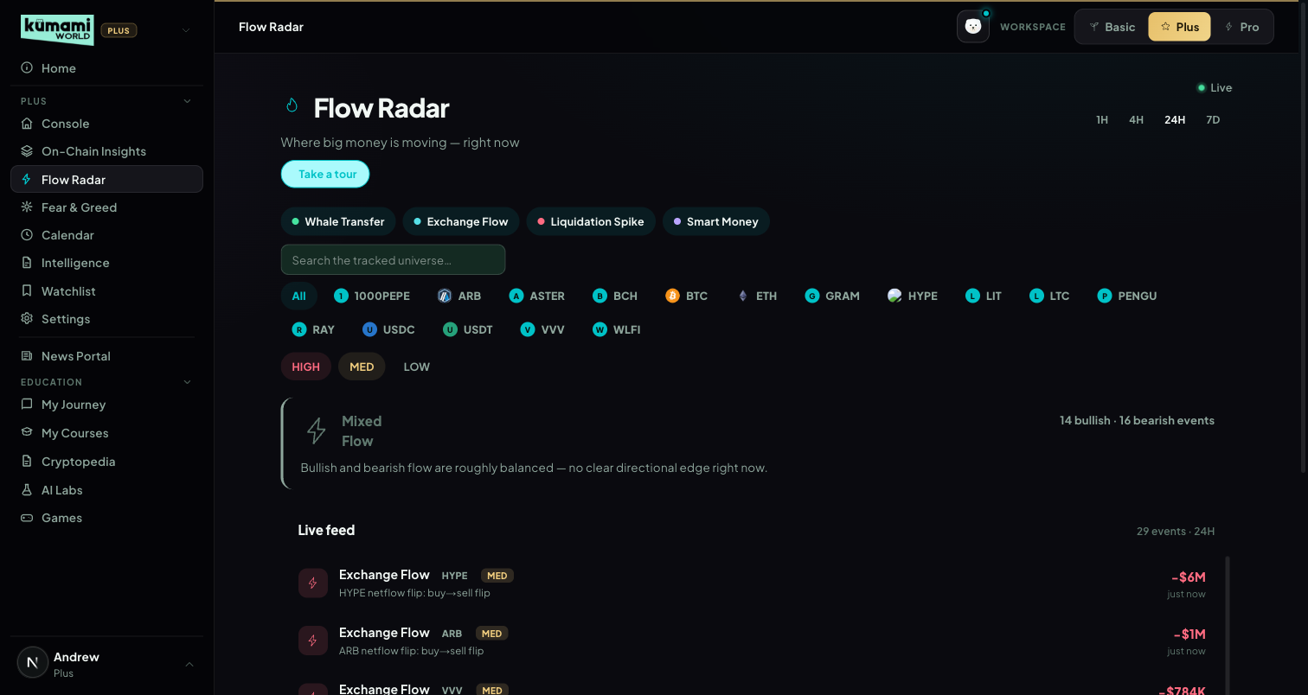
Figure: Flow Radar — event-type filter chips, asset chips, severity toggle, verdict band, live feed.

How the user uses it
Toggle the 1H/4H/24H window; tick event-type chips (Whale Transfer / Exchange Flow / Liquidation Spike / Smart Money) and asset chips to filter; use the severity toggle (HIGH/MED) to control noise; read the verdict band for the window's overall lean; scroll the live feed list, which paginates as more events load.

How we build it

Via API
Event type | API | HIGH | MED | Direction logic
Whale Transfer | /api/chain/v2/whale-transfer | > $100M | $10–100M | to exchange = Inflow (bearish) · from exchange = Outflow (bullish)
Exchange Flow | /api/exchange/chain/tx/list | > $500M | $100–500M | net direction over a 1H rolling window
Liquidation Spike | /api/futures/liquidation/coin-list | > $200M/h | $50–200M/h | always tagged “Sell Pressure” (doesn't yet distinguish long-flush vs short-squeeze direction at the event level)
Smart Money (Hyperliquid) | /api/hyperliquid/whale-alert | confidence > 0.8 | otherwise | open long = “Smart Money” (bullish) · open short/accumulation = “Accumulation”
Market Verdict Band — first match wins:
Condition | Verdict | Color
bearish $ > $500M AND ≥3 bearish events | Distribution Wave | red
bullish $ > $500M AND ≥3 bullish events | Broad Accumulation | green
total liquidation $ > $300M | Liquidation Cascade Detected | amber
≥3 bullish AND ≥3 bearish events | Mixed Flow | grey
else | Quiet Flow | grey
Bullish-leaning directions: Outflow, Buy Pressure, Support Wall, Accumulation, Smart Money. Bearish-leaning: Inflow, Sell Pressure, Resistance Wall. Each verdict ships a matching sentence and a stat line. Whales and forced liquidations move first — surfacing them live, filtered to a manageable 5-asset roster, is Plus's stickiest single feature.
Pro tier note: Pro removes the 5-asset roster restriction (full tracked universe already flows through the same bulk CoinGlass endpoints) and the severity filter (adds LOW), and layers two Pro-only additions — a Flow Balance Panel and cross-signal tags. See Pro §18.

4. Fear & Greed Index
A composite of five sourced, dated factors — not a bare number.

What it is
A full standalone tab (vs. just the index bar on Console) — a 5-metric weighted composite scored 0–100, with historical context.

Where it is
Tier: Plus.
Nav path: Sidebar → Plus (group) → Fear & Greed.
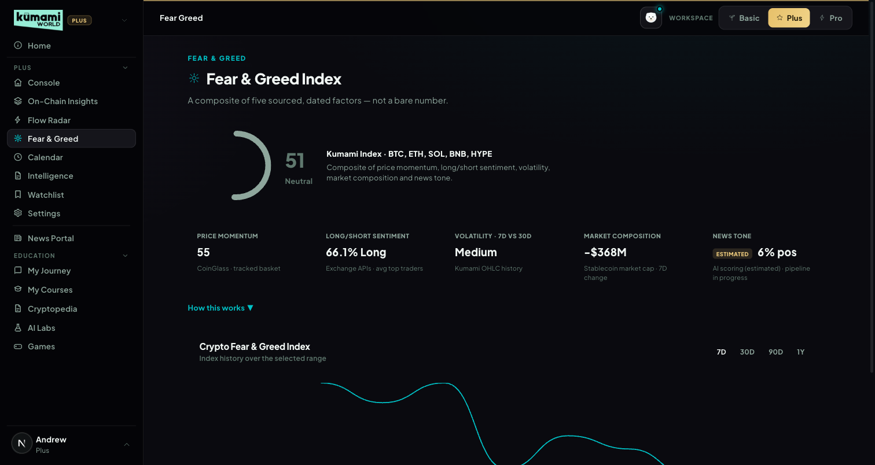
Figure: Fear & Greed Index — circular gauge, 5 sub-metric tiles, historical trend chart.

How the user uses it
Read the circular gauge (score + label) and the 5 sub-metric tiles below it; click “How this works” to expand the methodology explainer; switch the historical chart's range (7D/30D/90D/1Y) to see the trend.

How we build it

Via API
composite = Price Momentum×0.30 + Long/Short Sentiment×0.20 + Volatility×0.15 + Market Composition×0.20 + News Tone×0.15. Bands: 0–24 Extreme Fear · 25–45 Fear · 46–55 Neutral · 56–74 Greed · 75–100 Extreme Greed.
Sub-metric | Data source | Measures | Scoring
Price Momentum | Daily price history, weighted basket (BTC 50%/ETH 25%/SOL 10%/BNB 10%/HYPE 5%) | (price − 30D avg)/30D avg | >+20%→95 · >+10%→80 · −10..+10%→55 · ≥−20%→25 · else→5
Long/Short Sentiment | Long/short account ratio, same basket | % long, contrarian | >75%→95 · >65%→80 · >55%→62 · 45–55%→47 · 35–45%→32 · 25–35%→17 · <25%→5
Volatility (7D vs 30D) | OHLC history | 7D realized vol ÷ 30D realized vol | >1.5→7(High) · >1.2→22(High) · >0.9→50(Med) · >0.7→70(Low) · else→90(Low)
Market Composition | Stablecoin market-cap index | 7D stablecoin supply change, inverted | >+$5B→7 · >+$2B→25 · ±$2B→50 · ≥−$5B→75 · else→92
News Tone | Live Intelligence headlines, keyword heuristic (marked “Estimated” — no LLM classifier wired yet) | % recent headlines bullish | >75%→92 · >60%→75 · 40–60%→50 · 25–40%→27 · else→8
Known simplification: the historical chart plots the raw upstream Fear & Greed index history as a proxy trend line, not a full backfill of the platform's own 5-metric composite.
Fixed on 21 Sep 2026: the colour mapping was inverted in the rule engine (Extreme Greed rendered red, Extreme Fear green) — now Greed = green, Fear = red. The history chart has fixed colour bands (Extreme Fear 0–24 … Extreme Greed 76–100) and axis labels. Each sub-metric tile shows “unavailable” when its input fails, and the composite itself is flagged unavailable when all five inputs fail (no fake neutral 50). The one user-facing “CoinGlass” string was removed.

5. Calendar
The one Calendar for Plus and Pro: macro prints, token unlocks and Kumami team events on a month grid.
As built (v1.7): the automatic CoinGlass feeds are OFF by default — the Calendar shows only events the team adds. Two switches at the top of /admin/pro-calendar (“Macro events (CoinGlass)”, “Token unlocks (CoinGlass)”) turn each feed on or off for everyone; the switch shows “Saving…” until the database confirms, and who changed it last. A switched-off feed disappears everywhere (Calendar page, Console preview, both popups). Setting: Firestore pro_settings/calendar.

What it is
A month-grid calendar that merges three sources: macro economic releases and token unlocks from the market-data feed, plus events the Kumami team adds by hand in the admin panel (the spec's “editorial pipeline” for protocol events, Rachelle §7.1). Since 9 Oct 2026 it is the only calendar — Pro's old admin-only Calendar tab was merged into it, and its admin page now feeds this page.

Where it is
Tier: Plus and Pro (same page, same data for both).
Nav path: Sidebar → Plus (group) → Calendar. Pro users open it from the Plus workspace; old /world/pro?tab=calendar links (e.g. from the Daily Digest) redirect here and switch the workspace to Plus.
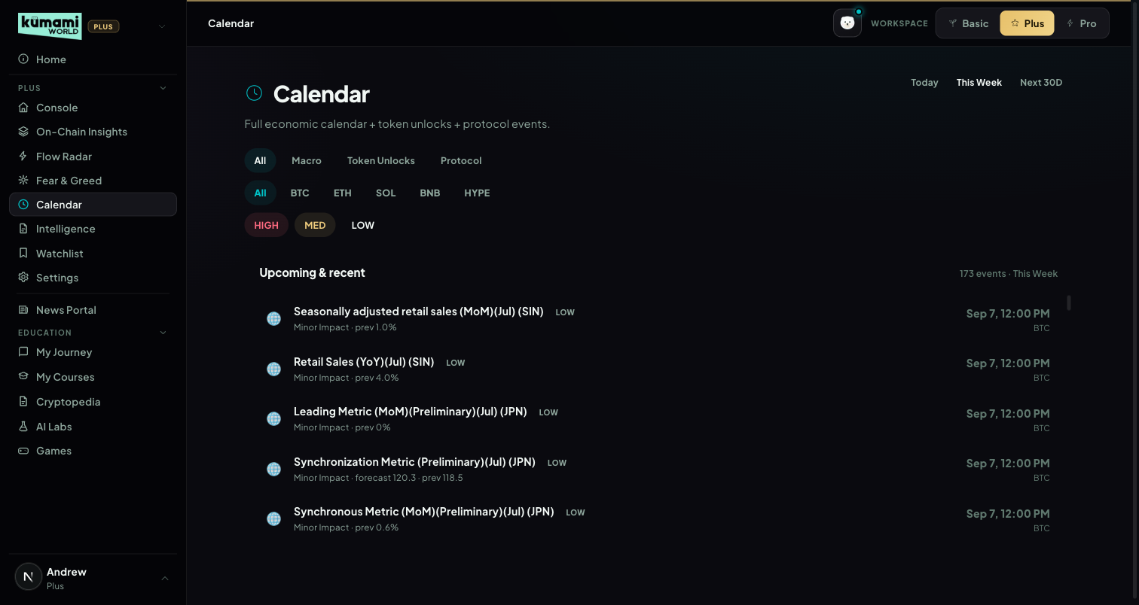
Figure (captured before the 21 Sep rebuild — shows the old list view; to be re-captured with the month grid).

How the user uses it
Read the “Next up” card at the top for the nearest upcoming event. Filter by type (All / Macro / Token Unlocks / Protocol & other), by asset (BTC/ETH/SOL/BNB/HYPE) and by impact (HIGH/MED/LOW toggles). Move between months with ‹ ›. Each day cell shows up to 3 events — team events (marked ★) first, then by impact — with “+N more”; hover an event for its category, impact and description. Within 24 hours of a qualifying high-impact event a popup appears once (Dismiss hides it).

How we build it

Via API
Macro events: /api/calendar/economic-data with start_time/end_time = 30 days back → 60 days ahead (without those parameters the endpoint only returns the past 30 days). Token unlocks: /api/coin/unlock-list. Both cached 1800s in the shared market cache (shared with Intelligence). The /api/market/calendar route itself is not cached so admin changes appear straight away. Each source fails independently to an empty list.
Event type | HIGH | MED | LOW
Macro (economic-data) | importance_level ≥ 3 | importance_level = 2 | importance_level ≤ 1
Token unlock (market cap > $50M only) | next unlock ≥ 5% of circulating supply | 1–5% | < 1%
Kumami team event | Impact chosen by the admin
Macro events count as market-wide (tagged BTC). Identical repeated releases from the feed are de-duplicated. Unlocks are dated on next_unlock_date. Popup rule (D-1 popup here and the Console attention popup): HIGH impact AND an asset in BTC/ETH/SOL/BNB/HYPE — team-added HIGH events always qualify. Code: src/lib/market/rules/calendarEvents.ts (pure, unit-tested) and src/lib/market/live/calendarPage.ts.

Via Admin Dashboard (manual)
Firestore pro_calendar (collection name is historical), authored at Content → Pro Dashboard → Calendar (/admin/pro-calendar): Title, Date, Time in UTC (blank = all day), Impact (High/Medium/Low), Category (Macro / Token unlock / On-chain / Regulatory / Project / Other), Affected assets (optional, comma-separated), Description → Publish or Save Draft. Existing events are listed below with Edit and Delete. Only published events reach the Calendar; Macro and Token unlock categories file under those types, everything else under “Protocol & other”. See Pro §14 for the admin screenshot.

Known gaps
- Token unlocks only ever show today's unlocks: on the current CoinGlass plan /api/coin/unlock-list returns rows whose next unlock is today (all 100 rows dated today on 9 Oct 2026). Future unlocks need a different endpoint or plan.
- No day / week / list-view toggle — month grid only (Rachelle §7.2 asks for day/week/month + list).
- The Today / This Week / Next 30D timeframe filter from the spec is not on the grid.
- No “Add to my events” button on the popup, and the D-1 popup fires when this page is opened, not app-wide on next login (the Console popup covers the landing screen).
- The feed has no protocol events; “Protocol & other” only shows team-added events.
- Console badge “CPI in 4h — expect volatility” (Rachelle §7.4) is not built; the attention popup is the closest equivalent.

6. Watchlist Plus
Per-asset live price, a flow Signal and a risk Status — personalization is the Pro upsell.
As built (v1.7): the 5 fixed coins (BTC/ETH/SOL/BNB/HYPE) with Signal and Status — no adding, no pinned coins, no extra coins, for every account. The “Open Watchlist Pro” button leads to the Pro version (Pro §19).

What it is
A live table of the fixed Plus roster, each row showing price, 24h change, a Signal (the most notable flow story for that coin) and a Status (up to two risk/positioning tags plus a regime label).
Asset roster: the same fixed 5-asset universe as the rest of Plus — BTC, ETH, SOL, BNB, HYPE — for every viewer (changed from an older 10-symbol list on 15 Sep 2026). The Console Watchlist preview reads exactly this data.

Where it is
Tier: Plus.
Nav path: Sidebar → Plus (group) → Watchlist Plus.
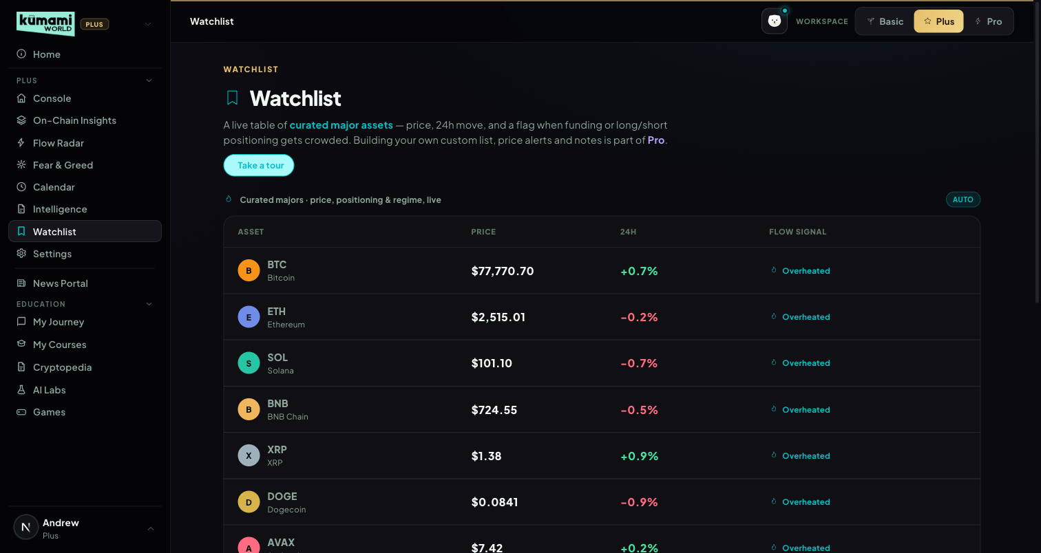
Figure (captured before the 21 Sep rebuild — shows a single “Flow signal” column; the live table now has separate Signal and Status columns).

How the user uses it
Read the table (Asset / Price / 24H / Signal / Status). Signal answers “is money moving into this?”; Status answers “is it risky right now?”. Plus viewers see the 5 assets read-only; “Your Watchlist” (pin your own tokens) and alerts are shown as Pro upsells (“Customize with Pro”, “Open Following & Alerts”).

How we build it

Via API
Per asset: Price + 24h: /api/futures/pairs-markets. Funding rate: /api/futures/funding-rate/oi-weight-history. Long/short ratio (perp assets only): /api/futures/global-long-short-account-ratio/history. Capped at 3 CoinGlass calls per asset; the whole payload is cached 300s per user.
Up to 2 action tags per asset (most severe wins):
Signal | Tag (color) | Threshold
Funding rate | Overheated (red) | > +0.10%
Funding rate | Short Heavy (amber) | < 0%
Long/short ratio | Crowded Long (amber) | > 70% long
Long/short ratio | Crowded Short (amber) | < 30% long
Tie-break: red > amber; within the same color, funding-rate tags outrank long/short tags. A separate, uncapped regime tag (Trending Up / Trending Down / Ranging) is derived from a same-direction approximation of OI vs. price (in practice “Coiling” can't occur live, since OI direction is approximated from price direction rather than fetched independently, to cap API call budget).
Signal column (src/lib/market/rules/watchlistSignal.ts), first match wins: (1) whale flow and smart money aligned in the same direction → “Multi-signal”; (2) Whale Accumulation / Distribution (2+ whale transfers in 24h, with the real $ total as the detail line); (3) a notable Spot Pulse verdict for that coin; (4) “Quiet”. Whale tags are available to Plus (they were wrongly Pro-gated before 21 Sep).
Known gap: liquidation-proximity tags (“Near Liq Zone” / “Watch Level”) exist in the rule engine but can't fire live — that data is tier-locked on the current CoinGlass plan.
Pro tier note: Pro rebuilds this single table into 3 sections — a real user-editable pinned watchlist, this same curated table, and a new whale-flow-scored “Also Worth Watching” list. See Pro §19.

7. Intelligence (removed from navigation)
Retired as a Plus tab on 21 Sep 2026 — it is not in Rachelle's latest Plus navigation (Calendar took its slot).

What happens now
/world/intel redirects to the Console, so old links and bookmarks still land somewhere useful. The Console's Intelligence preview was replaced by the Calendar preview (§1.4).

What still uses it
The Intelligence engine (src/lib/market/live/intel.ts: news articles + macro calendar + unlocks scored into A/B/C briefs by impact × timing) still runs behind the scenes: its headlines feed the News Tone sub-metric of Fear & Greed (§4). The detailed A/B/C rules are kept in v1.2 of this document.

8. Settings
Standard account management.

What it is
Profile, plan, notification preferences, language — a placeholder page today. Explicitly scoped as “not detailed in this brief — treat as placeholder pending separate spec,” so the current bare page is intentional, not a gap.

Where it is
Tier: Plus.
Nav path: Sidebar → Plus (group) → Settings.
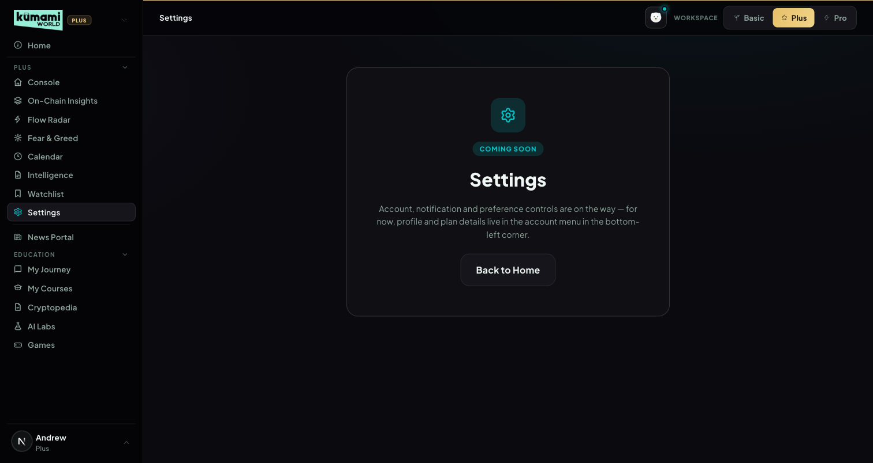
Figure: Settings — Coming Soon placeholder; profile/plan details currently live in the account menu instead.

How the user uses it
Nothing to configure yet — the page reads “Account, notification and preference controls are on the way; for now, profile and plan details live in the account menu in the bottom-left corner.” Click “Back to Home” to leave.

How we build it

Via Code only
A static placeholder component — no Firestore, no API, no admin panel.

Kumami Pro
Kumami Pro sits at /world/pro. Its sidebar has 16 tabs: Daily Digest and Following & Alerts at the top; News & Signals (Real-Time News, Alpha Room, Kumami Research, Market Analysis); Tools (Flow Radar Pro, Watchlist Pro, Spot Pulse Pro, Security Scanner, Market Cap Comparison, Airdrops & Whitelist); AI Tools (AI Portfolio, Crypto Address Tracker, Kuma AI Chat); and Events & Announcements at the bottom. The Pro sidebar lists only these Pro tabs (each workspace shows only its own tier — see the Kumami Plus intro). Pro users reach the Plus tools, including the shared Calendar, by switching to the Plus workspace; the Pro-only depth on Flow Radar (§18) and Watchlist (§19) follows the account, so it is there in the Plus workspace too. Security Scanner is the only remaining “Coming Soon” placeholder. Smart Money Tracker, Coin/Token Tracker and the Pro Fear & Greed slot were removed on 21 Sep 2026 (§3, §4, §12), and Pro's Calendar tab was merged into the shared Calendar on 9 Oct 2026 (§14). Non-premium users never reach any of this — they see a locked teaser instead.
Access (since v1.7): Pro = subscribed (users.isPremium) — nothing else. Admin and superadmin roles no longer unlock Pro; they only control the admin dashboard. This is enforced in the Pro tab gate, the sidebar lock, the server's Pro data (Flow Radar Pro, Watchlist Pro, Spot Pulse Pro, pinning) and the Crypto Address Tracker API. Non-subscribers opening any Pro tab get the Pro teaser and no Pro data is requested. Verified by the access-matrix QA (docs/qa/2026-10-10-plus-pro-tool-split.md).
Granting Pro (since v1.8): superadmins grant or remove Pro on the admin page Administration → Subscriptions (/admin/subscriptions), choosing 1 month, 3 months, 12 months or no end date. It works in every environment (comps, partners, staff, support fixes). A grant writes users/{uid} (isPremium, proUntil, proGrantedBy/At), a subscriptions record (planId pro-manual) and an admin_audit entry. Pro switches off automatically after the end date: every Pro check (server resolveTier, client AuthContext) treats a past proUntil as not Pro. Regular admins cannot grant Pro. This replaced the temporary Profile “Grant Pro / Remove Pro” testing buttons, which were removed.

1. Daily Digest
Rolls up every other Pro tool onto one scannable feed.

What it is
Aggregates the latest Kumami Research (pro_research), Real-Time News (pro_news), Airdrops (pro_airdrops), upcoming team-added Calendar events (pro_calendar, filtered to today-forward, top 3 — the full Calendar with the market feed lives at Plus §5), and the latest Alpha Room messages (top 3, system/image messages filtered out). Each section shows its 3 newest published items (sorted by publish time, newest first). Pure aggregation/sort/slice — no calculation logic. Each section links out to its full tab.
Disclosed gap: the component itself carries a static disclaimer: “Smart-money flow and a Fear & Greed read will join this digest once the market-data integration is live” — i.e. it documents that two upstream feeds are intentionally not yet wired.

Where it is
Tier: Pro only. Non-premium users never reach any of this — they see a locked teaser instead.
Nav path: Sidebar → Pro (workspace) → Pro → Daily Digest. Daily Digest is also the landing tab you reach first when you switch to the Pro workspace.
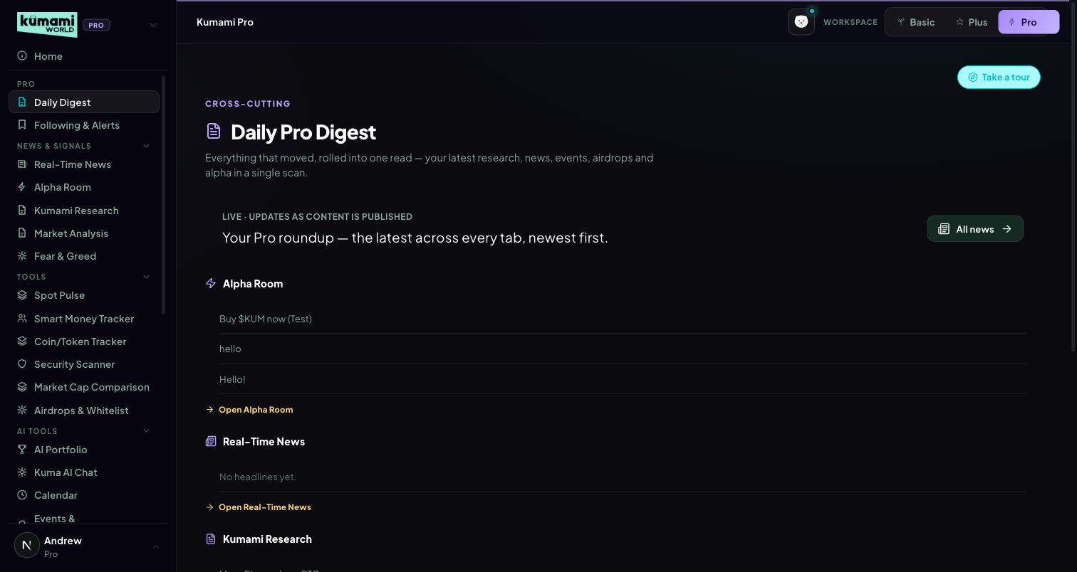
Figure: Daily Pro Digest — rolled-up feed of Alpha Room, Real-Time News, Kumami Research, Airdrops, and Calendar, each linking to its own tab.

How the user uses it
Scroll the single feed for a rollup of everything new; click any section's link (“Open Alpha Room”, “Open Real-Time News”, etc.) to jump into that tab directly.

How we build it

Via Admin Dashboard (manual)
Every source it aggregates is itself admin-authored — see Kumami Research (§13), Real-Time News (§10), Airdrops & Whitelist (§7), Calendar (§14), and Alpha Room (§11) below for each one's own admin panel. Daily Digest has no admin panel of its own; it purely reads and re-sorts those five collections.

Via API
None.

2. Following & Alerts
Per-user follow list + genuinely live price alerts.

What it is
A follow list + custom alerts persisted at users/{uid}/pro/state (Firestore). Price alerts are real: a public Binance WebSocket miniTicker stream covers 30 supported majors (BTC, ETH, SOL, BNB, XRP, DOGE, ADA, AVAX, LINK, MATIC, DOT, ARB, OP, LTC, TRX, NEAR, APT, SUI, TON, INJ, ATOM, UNI, AAVE, FIL, ETC, HBAR, ICP, RNDR, IMX, SEI).
Known gap: volume/sentiment-based triggers exist in the UI but are explicitly labeled “live monitoring soon” — not implemented yet.

Where it is
Tier: Pro only. Non-premium users never reach any of this — they see a locked teaser instead.
Nav path: Sidebar → Pro (workspace) → Pro → Following & Alerts. Also linked from the Watchlist tab in Plus (“Open Following & Alerts”).
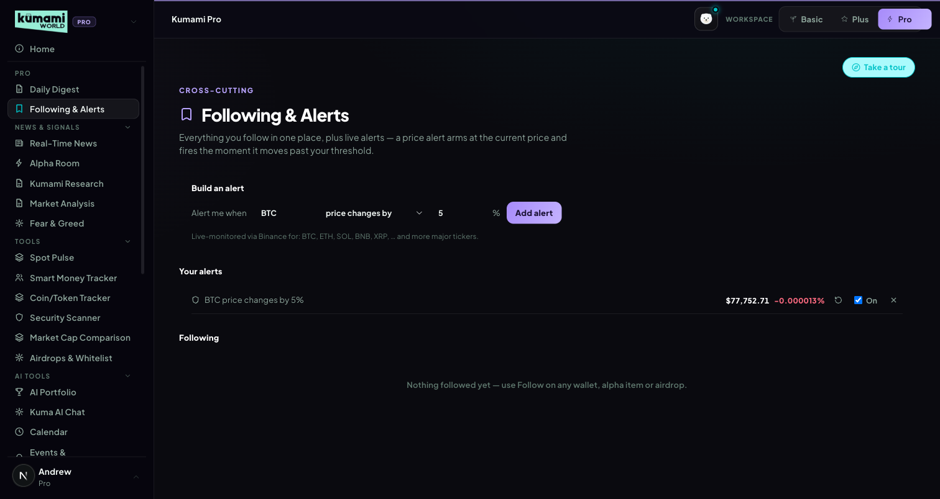
Figure: Following & Alerts — per-user follow list and price-alert configuration.

How the user uses it
Add assets to your follow list; set a price-move threshold per asset to arm an alert — it flips to TRIGGERED when the live price moves ≥ your threshold from the price it was armed at; click re-arm to reset the baseline.
Airdrops and whitelists you Follow (on their detail page) are listed under “Following” by name — e.g. “Lumen Network Airdrop · Airdrop”. If the team later removes or unpublishes one, the row says “An airdrop that is no longer listed” and you can unfollow it there.

How we build it

Via API
A public Binance WebSocket miniTicker stream (no key required) drives live prices for all 30 supported symbols. An alert “arms” at the first live price seen and flips to TRIGGERED when |Δ%| ≥ the user's threshold.

Via Admin Dashboard
None — the follow list and alert thresholds are entirely user-configured, written straight to the user's own Firestore document (users/{uid}/pro/state).

3. Smart Money Tracker (removed)
Removed from the Pro navigation on 21 Sep 2026. It was a “Coming Soon” placeholder with no data source and is absent from Rachelle's latest mockup. Old ?tab=smartmoney links fall back to the Daily Digest.

4. Coin / Token Tracker (removed)
Removed from the Pro navigation on 21 Sep 2026 for the same reason as §3. Old links fall back to the Daily Digest.

5. Spot Pulse Pro
Spot-vs-futures activity, per token — the same live panel as Plus.
As built (v1.7): the full tool, real-time (15s cache): the 5 anchors plus Watchlist Pro's 5 extra coins (row 2), 10-tile market-verdict thresholds (used when 8+ tiles have data), full alert cards, 4H/24H/7D. Row 2 comes from the same “consistent in Flow Radar” selection as Watchlist Pro (stablecoins excluded); the footer says whether it is the 7-day rule or the building-history fallback. Plus users see the 5-anchor tile on On-Chain Insights.

What it is
Status: LIVE since 9 Oct 2026. The tab renders the exact Spot Pulse panel from Plus On-Chain Insights (Plus §2.9) — 5 anchor tiles (BTC/ETH/SOL/BNB/HYPE), market-wide verdict, divergence alert cards and the 4H/24H/7D timeframe switch — instead of the old “Coming Soon” card. One Spot Pulse for both tiers for now.
What Pro gets on top today: a faster refresh (/api/market/spot-pulse caches 15s for Pro vs 60s for Plus). Pro's planned second row (top 5 trending coins by 24h spot volume) and its 10-tile verdict thresholds are already in the engine but stay off until the CoinGlass plan includes /api/spot/coins-markets.

Where it is
Tier: Pro only (Plus users see the same panel inside On-Chain Insights).
Nav path: Sidebar → Pro (workspace) → Tools → Spot Pulse Pro.
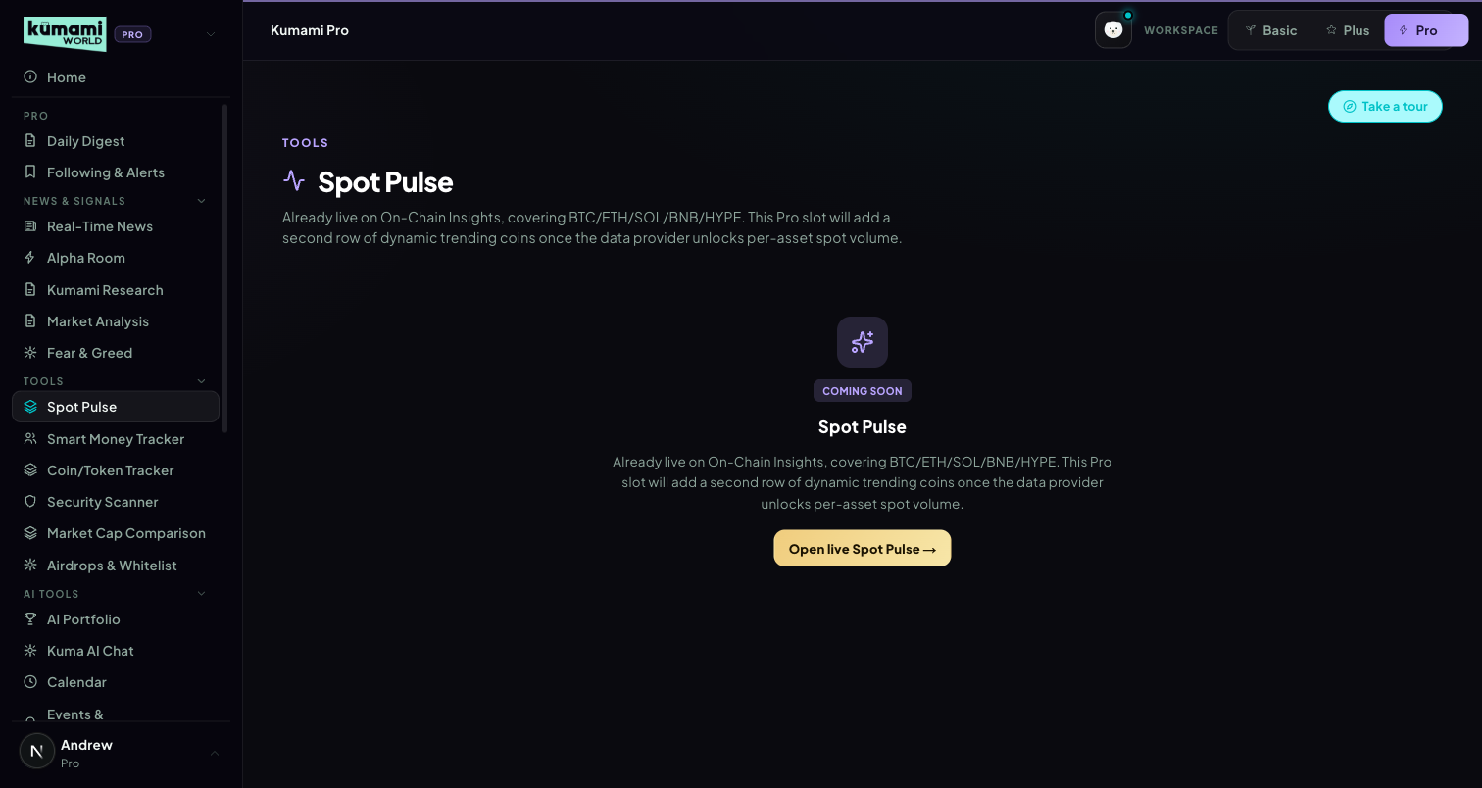
Figure (captured before 9 Oct — shows the old Coming Soon card; the tab now shows the live Spot Pulse panel).

How the user uses it
Pick a timeframe (4H/24H/7D), read the market-wide banner, then each coin's tile verdict (REAL BUYING, SPECULATIVE, DISTRIBUTION, ACCUMULATION, …) and the alert cards for the biggest divergences.

How we build it

Via API
Same pipeline as Plus §2.9: /api/spot/aggregated-cvd/history · /api/futures/aggregated-cvd/history · /api/futures/price/history · /api/spot/netflow-list, served through /api/market/spot-pulse.

6. Security Scanner
Contract- and wallet-level risk scoring before you interact.

What it is
Status: PLACEHOLDER — renders the generic “Coming Soon” card. Copy references honeypots, mint authority, and LP locks; no data source wired.

Where it is
Tier: Pro only. Non-premium users never reach any of this — they see a locked teaser instead.
Nav path: Sidebar → Pro (workspace) → Tools → Security Scanner.
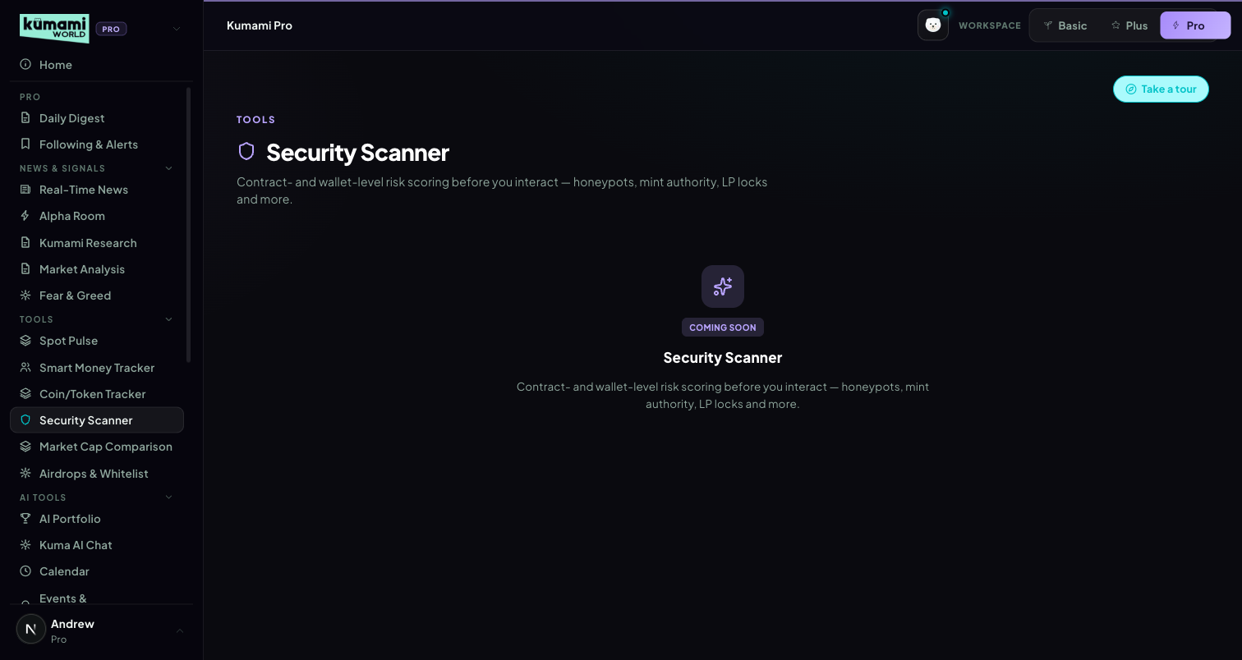
Figure: Security Scanner — generic Coming Soon placeholder card.

How the user uses it
Nothing to interact with yet.

How we build it

Not built yet
No Firestore, no API, no admin panel.

7. Airdrops & Whitelist
Admin-curated airdrop and whitelist opportunities with an eligibility checklist.

What it is
Status: LIVE (Firestore, real-time). Reads pro_airdrops (status == 'published'). Two sub-tabs (Airdrops / Whitelists), card grid → detail view with an eligibility checklist, deadline, estimated value, and a Follow toggle. No scoring — purely admin-entered content, sorted by createdAt desc client-side.

Where it is
Tier: Pro only. Non-premium users never reach any of this — they see a locked teaser instead.
Nav path: Sidebar → Pro (workspace) → Tools → Airdrops & Whitelist.
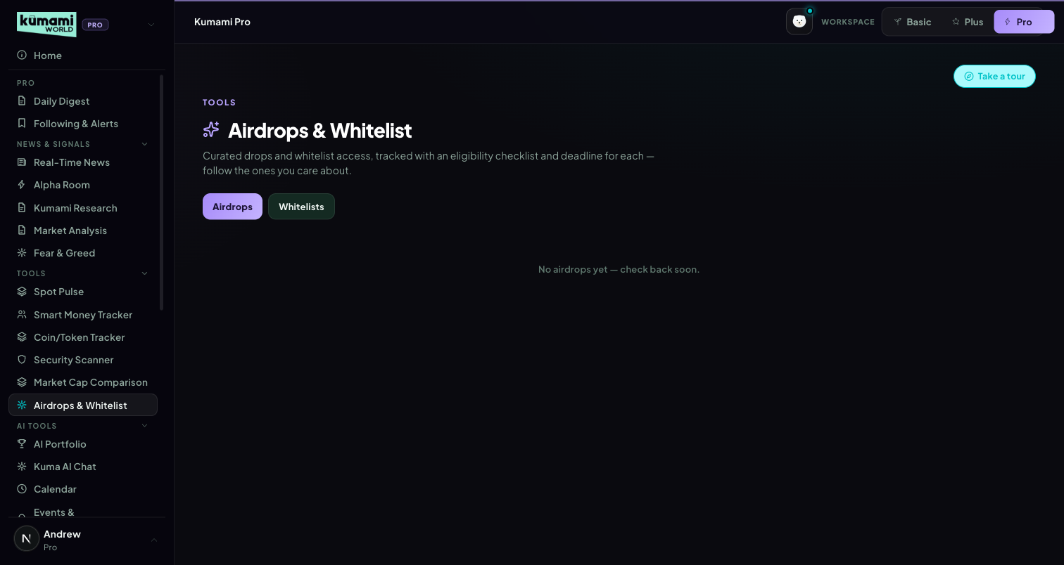
Figure: Airdrops & Whitelist — Airdrops/Whitelists sub-tabs over a card grid.

How the user uses it
Switch between the Airdrops and Whitelists sub-tabs; click any card to open its detail view — deadline, estimated value, and an eligibility checklist; click Follow to track one.

How we build it

Via Admin Dashboard (manual)
Firestore pro_airdrops, authored at Content → Pro Dashboard → Airdrops & Whitelist (/admin/pro-airdrops): Name, Category (airdrop dropdown), Description, Deadline (free text, e.g. “2d 4h” or “Not live”), Estimated value, Eligibility (checklist type), Accent color, and an “+ Add checklist item” builder → Publish or Save Draft.
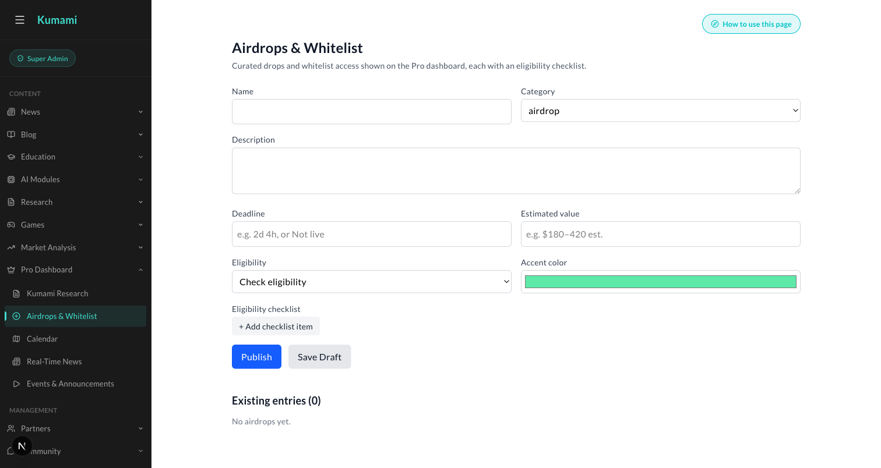
Figure: Content → Pro Dashboard → Airdrops & Whitelist — the admin form behind every Airdrops/Whitelist card.

8. AI Portfolio
Live holdings and pricing, plus an externally-scored risk scan.

What it is
Status: LIVE. Holdings read from users/{uid}.cryptoPortfolio (Firestore), priced live via /api/coingecko/markets (with 429 retry/backoff, plus a follow-up fetch for coins missing from the top-100 list). Add/Edit/Delete write straight back to Firestore. “Import Wallet” pulls live holdings from a pasted wallet address (same Alchemy wallet-scanning pipeline as the address tools) and merges them into the portfolio.
24h change: a real weighted figure — each holding's value 24h ago is derived from its own 24h price change and summed, so the hero card shows the portfolio's true move (up or down). The earlier hard-coded +2.3% was removed.

Where it is
Tier: Pro only. Non-premium users never reach any of this — they see a locked teaser instead.
Nav path: Sidebar → Pro (workspace) → AI Tools → AI Portfolio.
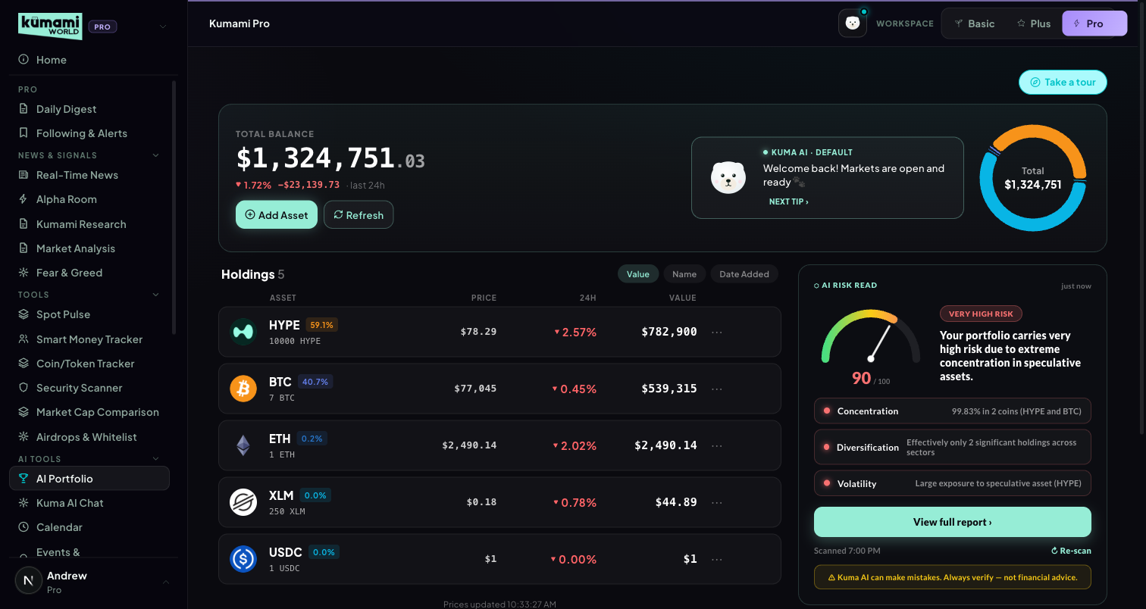
Figure: AI Portfolio — total balance, holdings table, AI risk-read panel.

How the user uses it
Click “Add Asset” to log a coin, amount, and price paid, or “Import Wallet” to paste an address and pull its holdings; click Refresh to re-pull live prices; click a holding's “…” menu to edit or delete it. Click “Scan my portfolio” (or “Re-scan”) to get a risk read — the result caches until your holdings change.

How we build it

Via API
Pricing: /api/coingecko/markets (429 retry/backoff). Risk scan: POST /api/portfolio-scan forwards {userId, totalValue, holdings[]} to an external n8n webhook (N8N_PORTFOLIO_SCAN_WEBHOOK_URL) and only validates/clamps the response shape (overall.score clamped 0–100, level clamped low/medium/high, dimensions limited to concentration/diversification/volatility/liquidity, actions capped at 4). The actual scoring logic — thresholds, weighting — lives outside this repo, in the n8n workflow; this codebase has no visibility into it. Results cache with a portfolio-hash staleness check (“Portfolio changed since this scan”).

Via Admin Dashboard
None — holdings are entirely user-entered, written straight to the user's own Firestore document.

9. Market Cap Comparison
“What if Coin A had Coin B's market cap?” — with real formulas.

What it is
Status: LIVE. Two searchable coin-selector dropdowns, a swap button, a stats comparison table (price/market cap/circulating supply/24h/rank/ATH/FDV), and an auto-generated insight sentence.

Where it is
Tier: Pro only. Non-premium users never reach any of this — they see a locked teaser instead.
Nav path: Sidebar → Pro (workspace) → Tools → Market Cap Comparison.
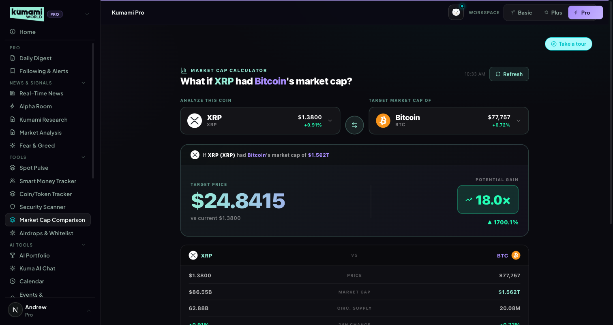
Figure: Market Cap Comparison — Coin A vs. Coin B selectors, swap button, stats table.

How the user uses it
Pick Coin A and Coin B from the two searchable dropdowns (defaults to XRP vs. BTC); click the swap button to flip them; read the comparison table and the auto-generated insight sentence below it.

How we build it

Via API
/api/coingecko/markets (top 100 coins, 429 retry/backoff).
How it's calculated: targetPrice = coinB.market_cap / coinA.circulating_supply · multiplier = targetPrice / coinA.current_price · pctChange = (targetPrice − current)/current × 100.

10. Real-Time News
Admin-curated, sentiment-tagged breaking news.

What it is
Status: LIVE (Firestore, real-time). Reads pro_news (status == 'published'). Each row: exact + relative time, headline with a sentiment dot (bull=green/bear=red/neutral=grey), one-line summary, tags, sentiment badge, source badge. Sorted newest-first.

Where it is
Tier: Pro only. Non-premium users never reach any of this — they see a locked teaser instead.
Nav path: Sidebar → Pro (workspace) → News & Signals → Real-Time News.
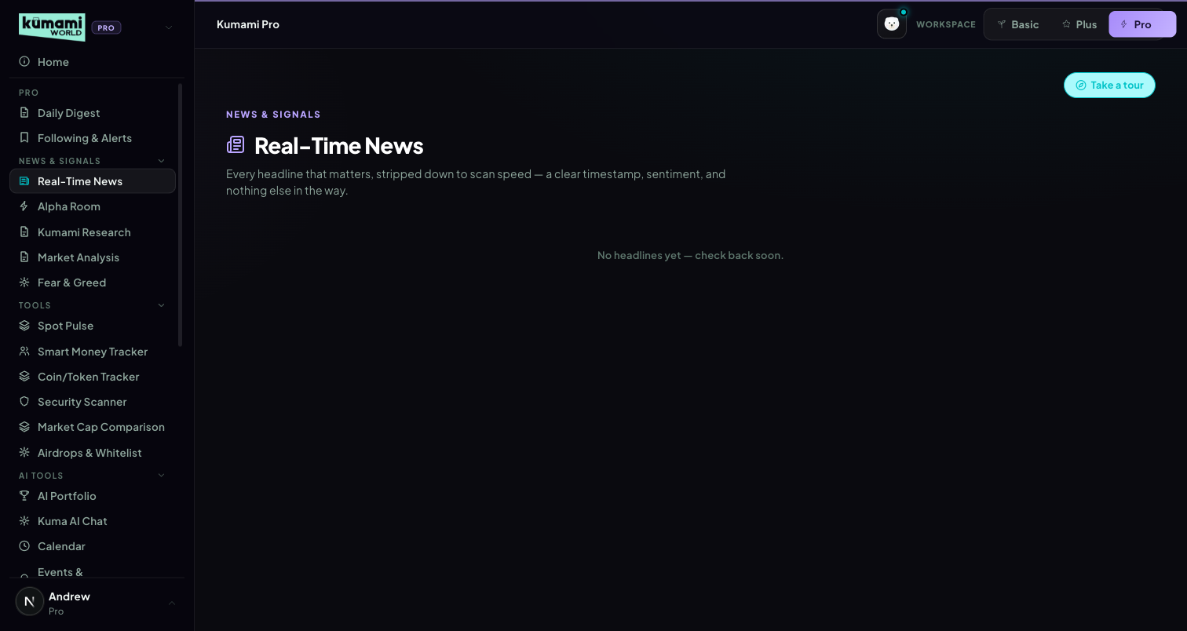
Figure: Real-Time News — sentiment-tagged headline list, newest first.

How the user uses it
Scroll the list; each row's sentiment dot (green/red/grey) gives an at-a-glance read before you even read the headline.

How we build it

Via Admin Dashboard (manual)
Firestore pro_news, authored at Content → Pro Dashboard → Real-Time News (/admin/pro-news): Headline, Sentiment (Bullish/Bearish/Neutral dropdown), Source (optional), one-line summary (optional), comma-separated Tags (optional) → Publish or Save Draft.
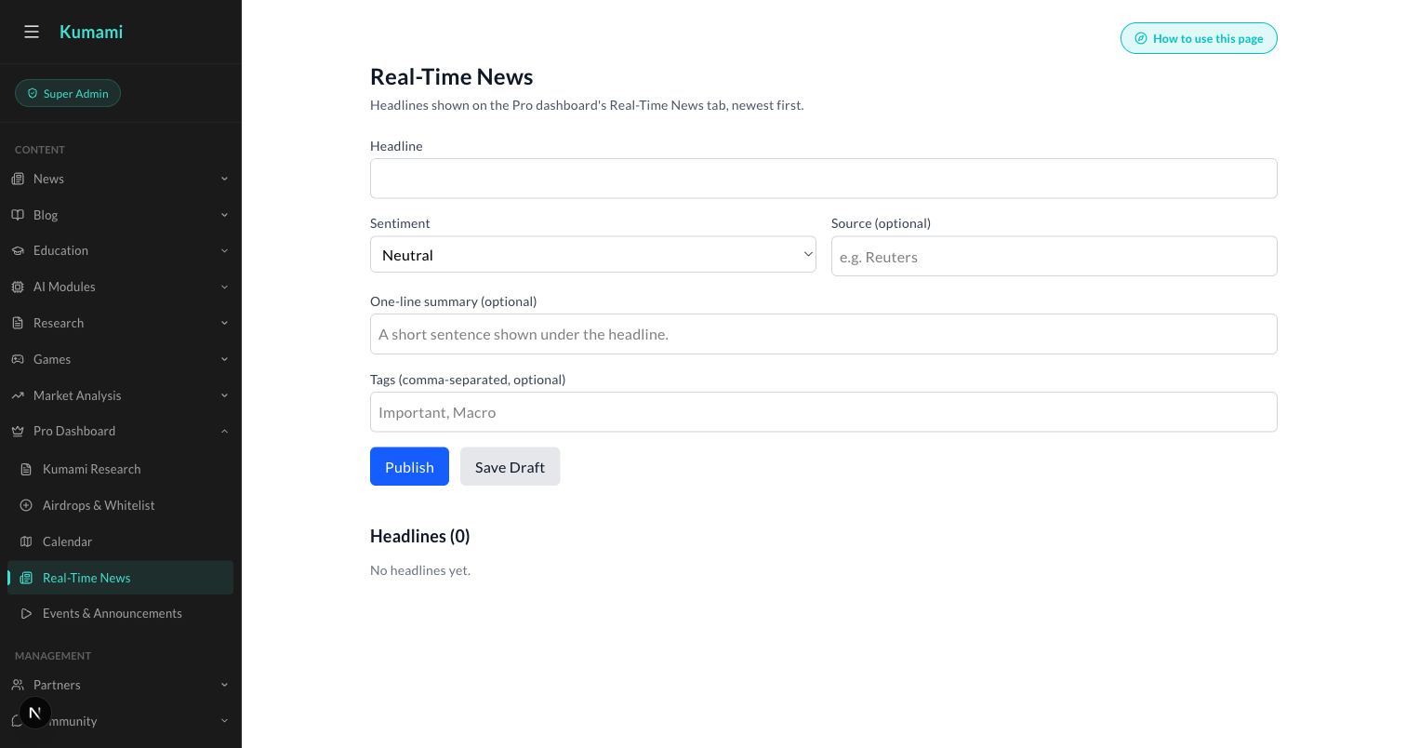
Figure: Content → Pro Dashboard → Real-Time News — the admin form behind every headline.

11. Alpha Room
A chat-style feed of curated alpha calls.

What it is
Status: LIVE (Firestore, real-time, read-only in this component). Reads the alphaRoom collection as a chat-style feed — system messages (centered pill) and user/image messages (chat bubble, avatar, timestamp).

Where it is
Tier: Pro only. Non-premium users never reach any of this — they see a locked teaser instead.
Nav path: Sidebar → Pro (workspace) → News & Signals → Alpha Room.
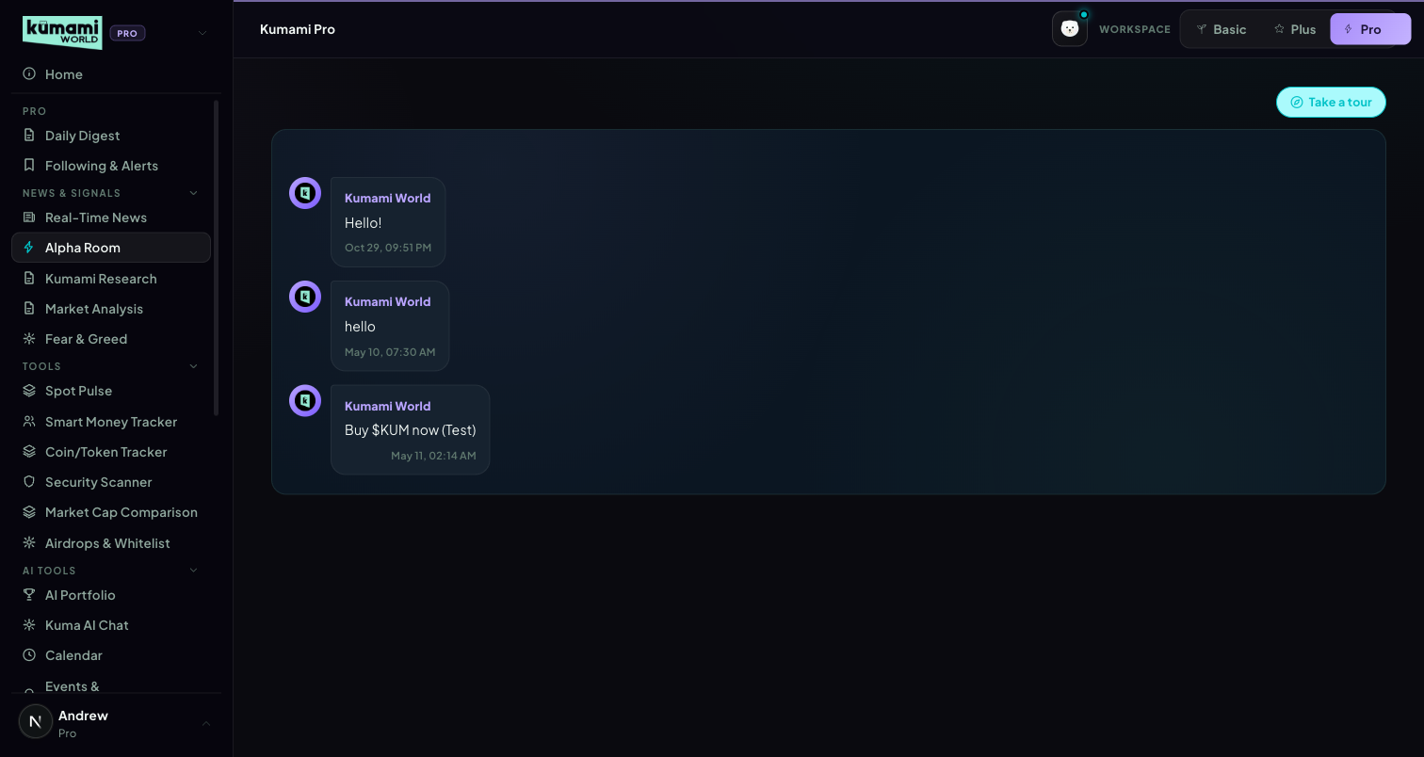
Figure: Alpha Room — chat-style feed of curated alpha calls, read-only for Pro users.

How the user uses it
Read-only feed — scroll to see the latest posted calls. There is no way to post or reply from this tab.

How we build it

Via Admin Dashboard (manual)
Firestore alphaRoom collection, authored at Management → Community → Alpha Room (/admin/alpha-room) — a chat-style composer where an admin types a message (or pastes/uploads an image) and sends it directly into the live feed as “Kumami World”. This resolves what the raw spec data left ambiguous (“presumably authored elsewhere”) — the admin panel is confirmed to be the actual write path, not a guess.
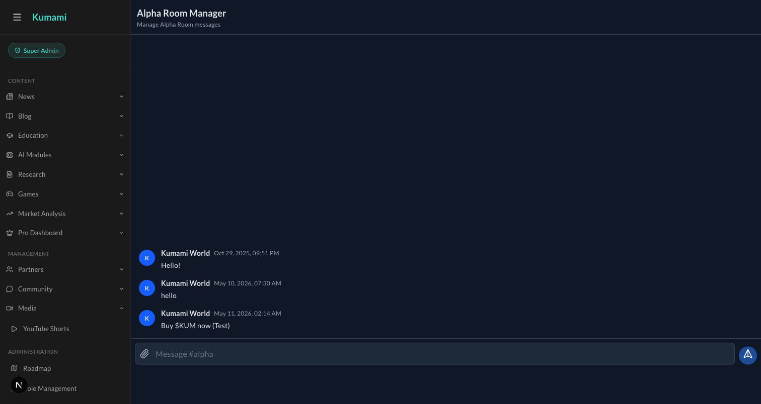
Figure: Management → Community → Alpha Room — the admin chat composer that writes directly into the live Alpha Room feed.

12. Fear & Greed (removed from Pro)
The Pro-only placeholder slot was removed on 21 Sep 2026. Pro users use the fully built Fear & Greed tab in the Plus workspace (Plus §4).

13. Kumami Research
Admin-authored research notes with a position call.

What it is
Status: LIVE (Firestore, real-time). Reads pro_research (status == 'published'). Each card: author name/role, relative timestamp, a position badge (long/short/neutral + asset), body text, and an optional “What this means for you” premium callout. No scoring — purely authored content.

Where it is
Tier: Pro only. Non-premium users never reach any of this — they see a locked teaser instead.
Nav path: Sidebar → Pro (workspace) → News & Signals → Kumami Research.
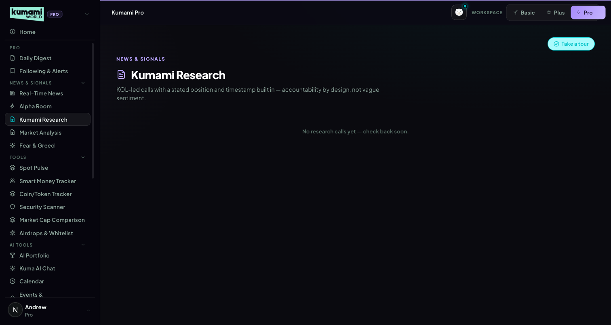
Figure: Kumami Research — author cards with a position badge and body text.

How the user uses it
Scroll the card feed; each card states its author, a long/short/neutral position badge on a specific asset, the reasoning, and (when present) a “What this means for you” callout.

How we build it

Via Admin Dashboard (manual)
Firestore pro_research, authored at Content → Pro Dashboard → Kumami Research (/admin/pro-research): Analyst name, Role/title, Position (long/short/neutral dropdown), Asset/ticker, “The call” body text, and an optional “What this means for you” field → Publish or Save Draft.
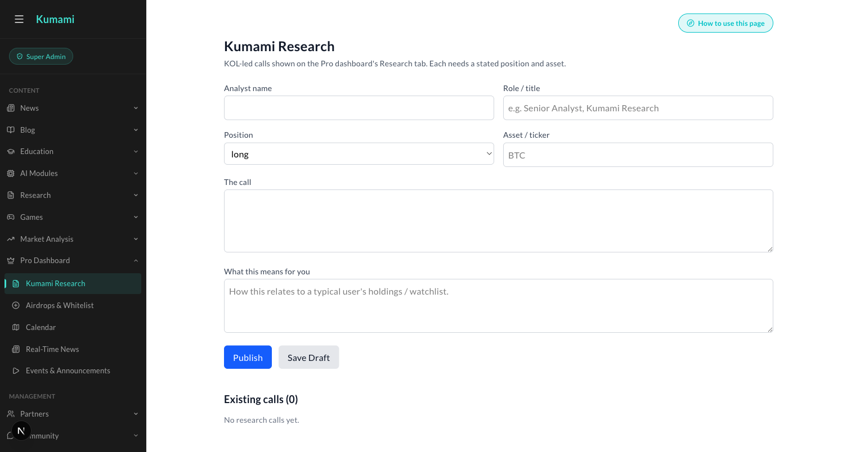
Figure: Content → Pro Dashboard → Kumami Research — the admin form behind every research card.

14. Calendar (merged into the shared Calendar)
Since 9 Oct 2026 Pro no longer has its own Calendar tab. Product decision (Andrew, 9 Oct 2026): one calendar — the Plus one — for everyone — with the admin-authored events from this tab merged into it.

What changed
- The Pro sidebar item was removed; Pro users open Calendar from the Plus workspace (Plus §5).
- /world/pro?tab=calendar (Daily Digest links, bookmarks) redirects to /world/calendar.
- Events published at /admin/pro-calendar now appear on the shared Calendar for Plus and Pro, marked ★ / “Kumami”, alongside the macro and unlock feed. Drafts stay hidden; edits and deletes show on the next load.
- The Daily Digest's Calendar section still lists the next 3 team-added events (pro_calendar only).

How we build it

Via Admin Dashboard (manual)
Content → Pro Dashboard → Calendar (/admin/pro-calendar) — fields and rules are described under Plus §5. New on 9 Oct: UTC time picker (blank = all day; older free-text times are still read), a “Token unlock” category, and an optional Affected assets field that powers the asset filter and the popups.
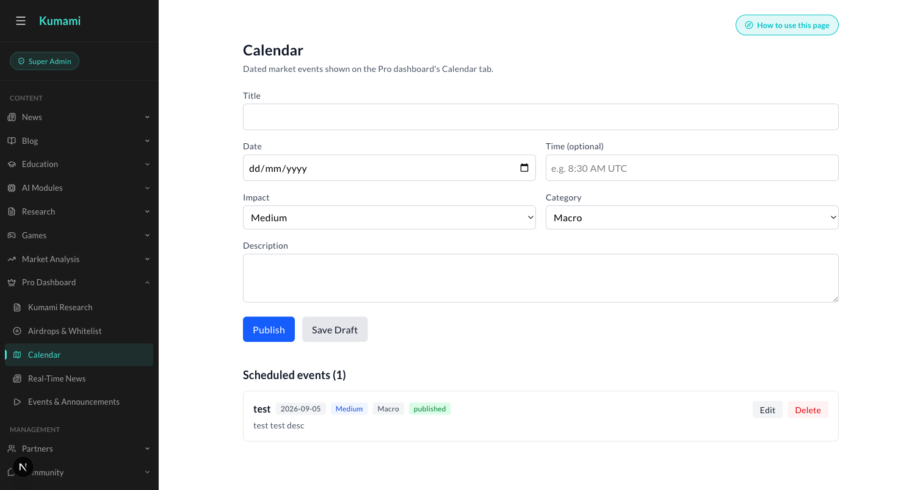
Figure: Content → Pro Dashboard → Calendar — the admin form behind every calendar event.

15. Events & Announcements
Live-streamed events with real-time audience Q&A.

What it is
Status: LIVE (Firestore, real-time, including a genuinely live sub-feature). Reads pro_events (pubStatus == 'published'), admin-authored, split into upcoming/past. Live events get a red “Live now” badge + embedded YouTube iframe.
How Q&A works: questions write to pro_events/{id}/questions, sorted by votes desc, with one-vote-per-user upvoting, a profanity/link/length moderation filter, and a client-side rate limiter before writes. Past events show a “Watch replay” toggle for the same embed. One of the more fully-built live features on the Pro surface — real-time, moderated, rate-limited audience interaction, not just static content.

Where it is
Tier: Pro only. Non-premium users never reach any of this — they see a locked teaser instead.
Nav path: Sidebar → Pro (workspace) → Events & Announcements. (Ungrouped — sits below the AI Tools group in the sidebar.)
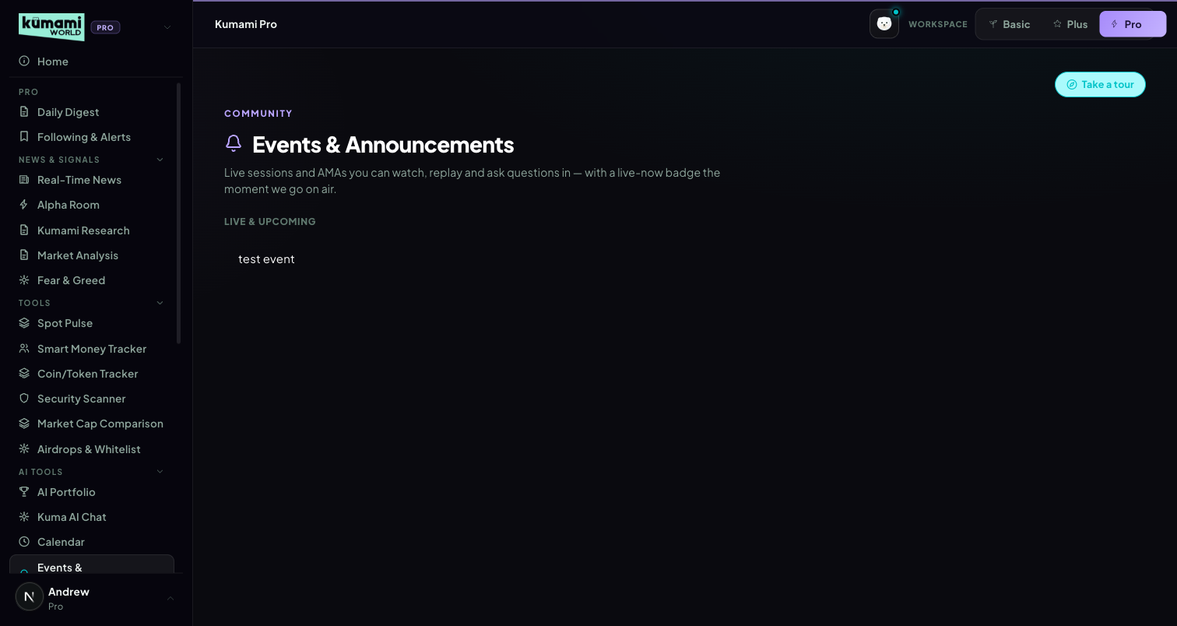
Figure: Events & Announcements — Live & Upcoming list; live events show a Live-now badge and embedded video with Q&A.

How the user uses it
Click a live event to watch the embedded stream and submit/upvote questions in the Q&A panel; click a past event to watch the replay via the same embed.

How we build it

Via Admin Dashboard (manual)
Firestore pro_events, authored at Content → Pro Dashboard → Events & Announcements (/admin/pro-events): Title, Date/time label, Host, Status (upcoming/live/past dropdown), YouTube video (id or URL), and a “Live now” checkbox (shows the Live badge + enables audience Q&A) → Publish or Save Draft.
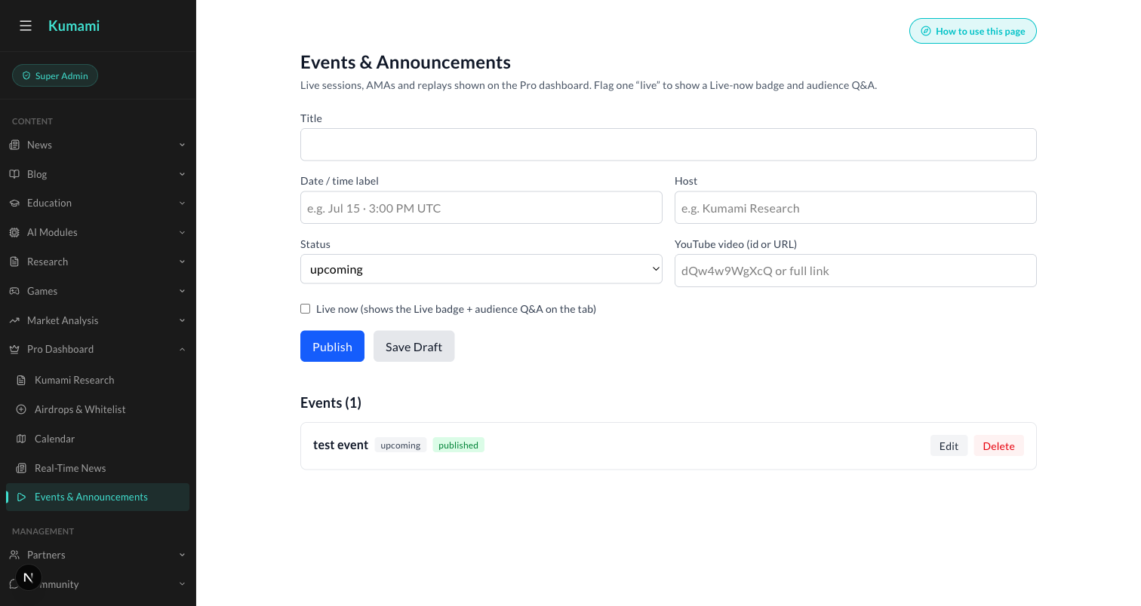
Figure: Content → Pro Dashboard → Events & Announcements — the admin form behind every event, including the Live-now toggle.

16. Market Analysis
A curated carousel of admin-authored market takes.

What it is
Status: LIVE (Firestore, real-time). Reads marketAnalysis (top 5 by createdAt desc), a hero/carousel layout with prev/next navigation, asset badge, delta badge, tag pill (Bullish/Bearish/Rotation/On-chain), author chip. Optional fields degrade gracefully if absent. No computed analysis — purely authored content with presentational formatting.

Where it is
Tier: Pro only. Non-premium users never reach any of this — they see a locked teaser instead.
Nav path: Sidebar → Pro (workspace) → News & Signals → Market Analysis.
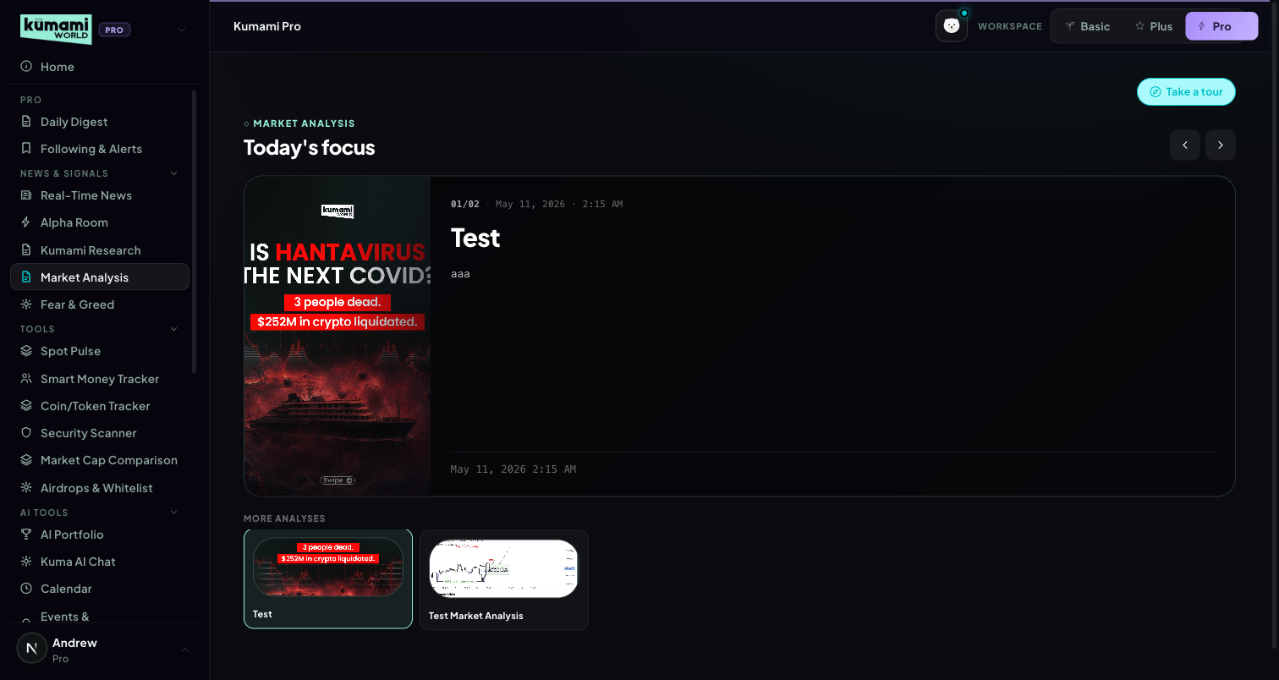
Figure: Market Analysis — hero carousel of the latest analysis, with More Analyses thumbnails below.

How the user uses it
Use the ‹ › arrows to move through the latest analyses, newest first; click a thumbnail under “More Analyses” to jump straight to it.

How we build it

Via Admin Dashboard (manual)
Firestore marketAnalysis, authored at Content → Market Analysis → Publish Market Analysis (/admin/market-analysis): Title, Content, and an Image upload → Publish Market Analysis.
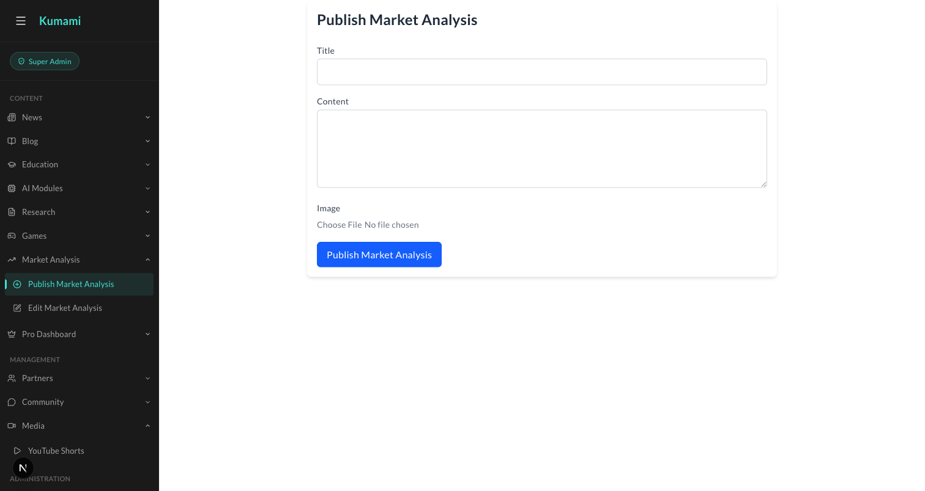
Figure: Content → Market Analysis → Publish Market Analysis — the admin form behind every carousel card.

17. Kuma AI Chat
Two products in one tab: general AI chat, and a live on-chain whale-wallet tracker.

What it is
Status: LIVE — the most substantively “real” integration in the whole Pro surface.
General chat: per-user rooms at users/{uid}/chatrooms/{roomId}/messages (Firestore real-time). Sending a message posts to an external chat API (the project's existing n8n backend). Prompt-snippet suggestions, custom markdown rendering, typing indicator, infinite-scroll pagination, room create/delete.
Crypto Address Tracker (default bot room): lets users watch up to 20 EVM wallets (ETH/Base/Arbitrum) with per-wallet USD alert thresholds and mute durations (1h/4h/24h). Wallet stats (balances, NFT counts, tx counts, top holdings) are fetched live via the Alchemy SDK server-side (Firebase ID token verified) — genuinely live on-chain data, not mocked. Alerts render direction (in/out), amount, chain, counterparty, USD value, and explorer links (Etherscan/Basescan/Arbiscan). This tab touches a real external chain-data provider (Alchemy) rather than Firestore-only content — the closest thing on the Pro surface to genuine on-chain intelligence today.

Where it is
Tier: Pro only. Non-premium users never reach any of this — they see a locked teaser instead.
Nav path: Sidebar → Pro (workspace) → AI Tools → Kuma AI Chat.
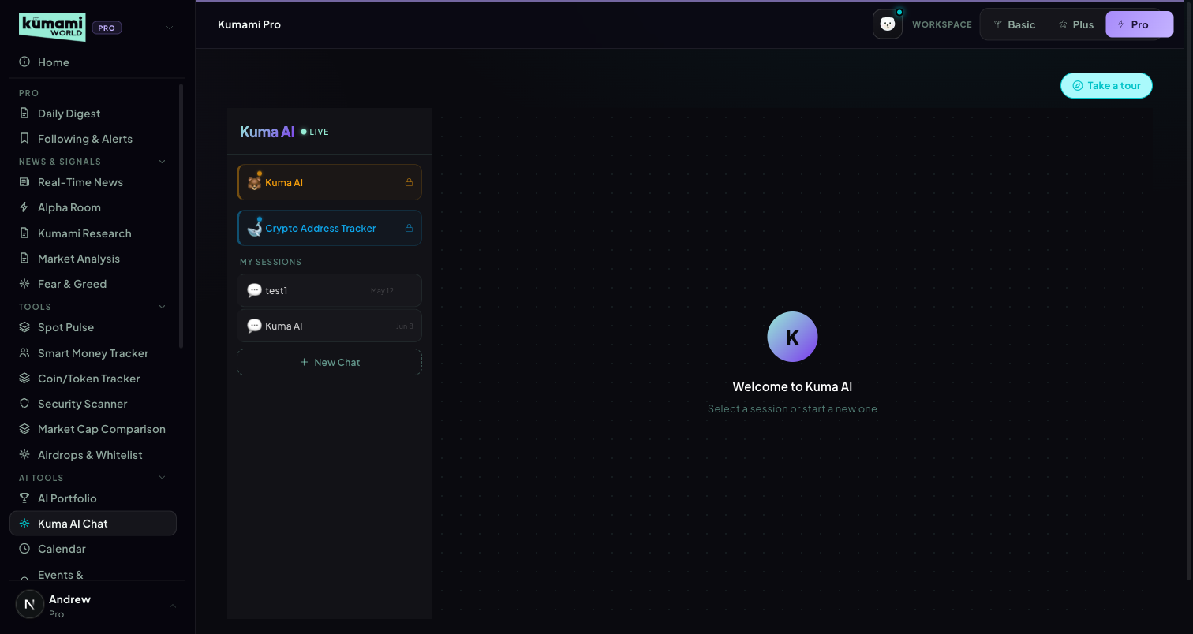
Figure: Kuma AI Chat — room list (Kuma AI, Crypto Address Tracker, My Sessions) with the main chat panel.

How the user uses it
Click “New Chat” to start a general conversation, or open the default “Crypto Address Tracker” room to add up to 20 wallet addresses with a USD alert threshold and mute duration each; past sessions are listed under “My Sessions” for quick resume.

How we build it

Via API
General chat messages post to the project's existing n8n chat backend. Wallet stats and live on-chain activity for the Address Tracker are fetched server-side via the Alchemy SDK (Firebase ID token verified) — real on-chain data, not mocked.

Via Admin Dashboard
None — rooms, messages, and tracked wallets are entirely user-configured.

18. Flow Radar Pro
Pro-tier enhancements on top of Plus §3 — same page, same feed, extra depth once tier === 'pro'.
As built (v1.7): its own Pro page and sidebar entry (Pro → Tools → Flow Radar Pro, /world/pro?tab=flowradar), subscribers only, real-time: every coin, HIGH/MED/LOW, Flow Balance panel, cross-signal outlines, multi-coin filter, 7D timeframe.

What it is
Two additions layered onto the Plus Flow Radar feed: a Flow Balance Panel, and cross-signal tags. Also removes Plus's asset-roster restriction (full tracked universe) and severity filter (adds LOW); the real-time delivery is unchanged since Plus already ships without delay.
Flow Balance Panel: a fixed 24h-window bull/bear USD split computed from the event feed — bullishUsd, bearishUsd, netUsd, bullish %, bearish %, and a 5-band verdict (Strong Accumulation: net > $500M · Accumulation: > $100M · Balanced: ≥ -$100M · Distribution: ≥ -$500M · Heavy Distribution: below that). The window is fixed at 24h regardless of the page's own 1H/4H/24H toggle.
Cross-signal tags: each event is checked against 3 rules, first match wins, plus a fallback: (1) whale outflow + Spot Pulse verdict in {REAL BUYING, ACCUMULATION} → green “Spot Pulse confirming”; (2) liquidation spike (Sell Pressure) + Console regime Bearish → red “Regime confirming”; (3) smart-money event + the same asset already showing 2+ same-direction whale events in the last 24h (the same signal Watchlist Pro's “Whale Accumulation” tag uses) → green “Watchlist confirming”; fallback: whale outflow + Fear/Extreme Fear on the Fear & Greed Index → green “Regime shift confirming”. Shown as a colored left-border outline on the event row with a tooltip, not a separate visible badge, to keep the feed scannable.

Where it is
Tier: Pro only — Sidebar → Pro → Tools → Flow Radar Pro (/world/pro?tab=flowradar). (Before v1.7 this was a Pro layer on the Plus page.) Reached via the Plus workspace (the Pro sidebar lists only Pro tabs). The panel and outlines render automatically for a Pro account, whichever workspace is selected.

How the user uses it
Read the Flow Balance Panel above the live feed for the last 24h's net bullish/bearish USD split and verdict; hover a highlighted event row to see which cross-signal rule fired, in the tooltip.

How we build it

Via API
Rule engines: src/lib/market/rules/flowBalance.ts (panel) and flowCrossSignal.ts (tags). Cross-signal context is built from 3 independently 4-second-timeout-guarded fetches (Spot Pulse, Console, Fear & Greed) so a slow upstream degrades only that one signal rather than the page; the Watchlist whale-tag input is computed directly from the same 24h event buffer already in scope in this route (not a second network call to the Watchlist endpoint, which only ever returns 5 fixed anchors and would silently never match).
Known gap: the significance/baseline detection engine (Rachelle's spec §1.7) is not implemented — it needs a new daily scheduled-job mechanism this repo doesn't have yet. The $500M / event-count / $300M thresholds are carried over unchanged from Plus and are not yet re-validated against real Pro-scale (100+ asset) event volume, consistent with the spec's own “Open items.”

19. Watchlist Pro
Pro-tier rebuild of Plus §6's single table into 3 sections — same page, extra sections once tier === 'pro'.
As built (v1.7): its own Pro page and sidebar entry (Pro → Tools → Watchlist Pro, /world/pro?tab=watchlist), subscribers only: the 5 anchors, your own coins (up to 15; add/remove — on phones via the × next to the coin) and 5 extra coins. Extra coins = most consistent in Flow Radar over the last 7 days (days present, then USD; stablecoins excluded). Daily history (Firestore flow_daily) started on 10 Oct 2026; until 7 days exist the list is filled from the 24h whale-flow scoring, then from the coins seen so far, labelled “building 7-day history (n/7 days)”.
v1.8: the 7-day history was backfilled for 4–9 Oct 2026 from CoinGlass history (whale transfers ≥ $5M with an exchange side, and cross-exchange hourly liquidation spikes; smart-money and netflow flips can't be rebuilt), so the 7-day rule is active now. Script: scripts/backfill-flow-history.ts (run once per Firebase project; days marked backfilled). Wrapped/staked versions of the anchors (WBTC, WETH, stETH…) are excluded alongside stablecoins.

What it is
“Your Watchlist”: a real, user-editable custom pin list (add/remove any tracked asset), capped at 15. The existing curated majors table, unchanged. “Also Worth Watching” (Section C): up to 5 additional assets — outside the user's pins and the curated roster — surfaced from real whale-flow scoring over the last 24h of Flow Radar events.
Section C scoring uses 3 of the spec's 5 criteria: Sustained Accumulation (net outflow > $50M, +3), Multi-Event Bullish (3+ events with at least 1 HIGH severity, +3), Coordinated Smart Money (2+ same-direction smart-money events, +4) — with multipliers (×1.5 if a HIGH-severity event landed within the last 6h; ×(criteria count × 0.5 + 1) if multiple criteria fire on the same asset), sorted descending, top 5 shown.

Where it is
Tier: Pro only — Sidebar → Pro → Tools → Watchlist Pro (/world/pro?tab=watchlist). Previously: Sidebar → Plus (group) → Watchlist, in the Plus workspace. Since 10 Oct 2026 the Pro sections follow the ACCOUNT (previously they also required the Pro workspace, which would have hidden them once Watchlist left the Pro sidebar).

Figure: Watchlist (Pro) — “Your Watchlist” with a {pinned}/{cap} counter, the curated table below it, and “Also Worth Watching” with a ◆ marker and reason tooltip on each row.

How the user uses it
Add or remove assets to build a personal watchlist, up to the 15-asset cap (the header shows “{pinned}/{cap} assets tracked”; an empty state prompts adding the first one). Read “Also Worth Watching” for assets the platform's whale-flow data is already flagging that aren't on the user's radar yet — hover a row's ◆ marker for the reasons it was surfaced.

How we build it

Via API
Pin cap: pinCap(tier) in src/lib/market/gating.ts (15 for Pro, 0 otherwise) — a separate cap from the fixed-table watchlistSlots(tier) used for Section A/curated slicing. Section C: computeSectionC() in src/lib/market/rules/watchlistSectionC.ts, fed by the same flow-radar event cache Flow Radar Pro (§18) already reads, so it costs no extra CoinGlass calls; each row's price/24h/tags reuses the existing buildAsset() pipeline (a cache hit in the common case).
Known gap: 2 of the spec's 5 Section C criteria are deliberately deferred — Volume Spike and “Significance Chip Fired” — both depend on data/engines not yet built (per-asset volume history; the significance/baseline engine noted under §18). The spec's “top-30-by-market-cap” pre-filter is also not applied — scoring runs across the same universe Flow Radar already tracks. Saved multiple lists, wallet-address rows inside the watchlist, price/whale alerts on pinned assets, and a historical trail remain Pro upsell placeholders, not built.

20. Crypto Address Tracker (standalone)
Paste any wallet, get a readable profile — a new standalone Pro page, not to be confused with the similarly-named bot room in Kuma AI Chat.

What it is
A one-shot wallet lookup tool: paste any EVM address, get portfolio value, holdings, a behavioral tag, and recent activity. Distinct from the existing “Crypto Address Tracker” bot room inside Kuma AI Chat (Pro §17) — that one is a saved, alert-driven wallet-watching room for up to 20 addresses; this is an unsaved, single-address read. Same underlying Alchemy data source and no new paid vendor, but a separate API route that doesn't touch Kuma AI Chat's existing contract.
Built: portfolioValueUsd + holdings (top-10 ERC20 tokens plus native ETH, priced via CoinGecko, sorted by value with % of portfolio); a single “Whale” tag when portfolio value ≥ $10M (the only behavioral tag shipped — see gaps below); transaction count and first-seen date; recent activity (last 10 transfers merged across in/out, with direction, asset, amount, counterparty address, and a block-explorer link).

Where it is
Tier: Pro only. Non-premium users never reach any of this — they see a locked teaser instead.
Nav path: Sidebar → Pro (workspace) → AI Tools → Crypto Address Tracker.

Figure: Crypto Address Tracker — address input, then a portfolio-value header with Whale tag, a stat grid, a Holdings list, and a Recent activity list.

How the user uses it
Paste any 0x… EVM address and click “Look up”; read the portfolio header (value + Whale tag if applicable), the stat grid (Portfolio Value / Realised PnL / Win Rate / Transactions / First Seen), the Holdings list, and Recent activity — each row links out to Etherscan.

How we build it

Via API
GET /api/wallet-profile — Firebase-ID-token gated, validates the 0x… address format, then fetches wallet summary, token balances, and transfers from Alchemy (Ethereum mainnet). Every individual Alchemy call is independently 8-second-timeout-guarded with a typed empty fallback, so one slow upstream degrades only that section instead of 500ing the whole page (fixed a real bug during build: an unguarded Promise.all of 6 Alchemy calls 500'd the route once when a single call hit ETIMEDOUT). Holdings are priced via a self-fetch to /api/coingecko/markets.
Known gaps (documented, not faked): Realised PnL and win rate need full FIFO trade-history reconstruction — not built, shown as “—”. Exchange-vs-cold-wallet labels on activity, “net outflow from exchanges,” and a “consistent accumulator” flag all need a verified CEX hot-wallet address list; hand-typing addresses from memory was considered and deliberately rejected during build — a wrong address silently mislabels real activity, which is worse than the plain in/out + counterparty shown today. Contract-risk flagging needs a GoPlus Security API integration that doesn't exist anywhere in this codebase (Security Scanner, which would own it, is itself an unbuilt Pro placeholder — see Pro §6). The “Kumami AI Read” narrative needs an LLM key, not wired into this app anywhere yet (same gap as Console/Flow Radar's hardcoded-template sentences). Linked-wallet visualization needs separate wallet-clustering heuristics, not implemented. Base/Arbitrum balances are read where available, but this project's Base/Arb Alchemy keys are currently placeholder/invalid — a pre-existing gap, not introduced by this feature.

